**AWS ASSIGNMENT**

1. **Create a virtual network with 2 subnets. Each subnet should have 16 Ips only.**

Go to the AWS management console and search VPC. Click on Create VPC.

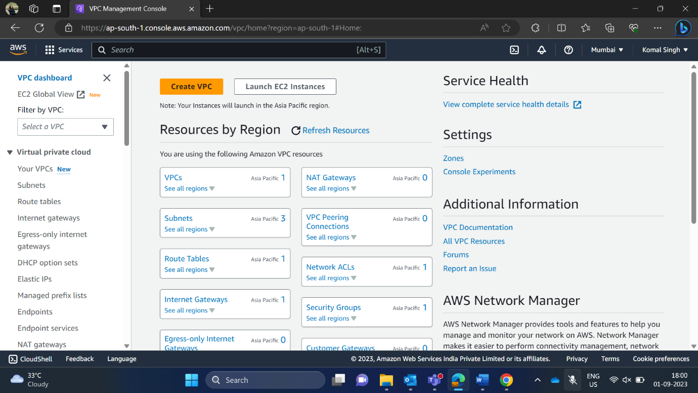

Now, I have given the name of my VPC is my-project. In IPv4 CIDR block I have used 15.0.0.0/27 as 10 is available by default, here in CIDR notation I have used 27-bit prefix so that I will get 32 IPs in which I can further divide it into two subnets of 16 IPs each.

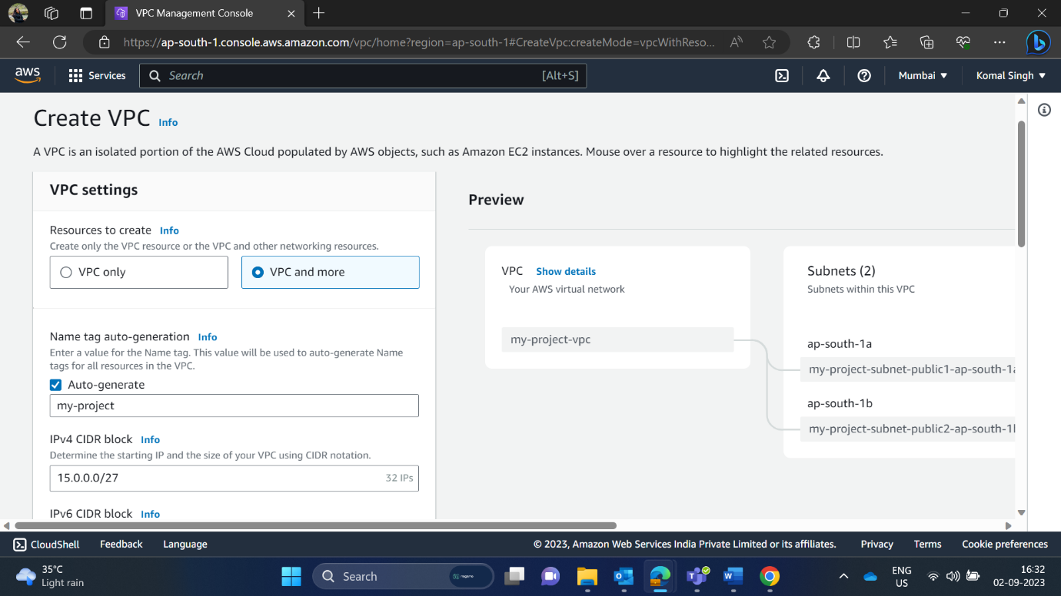

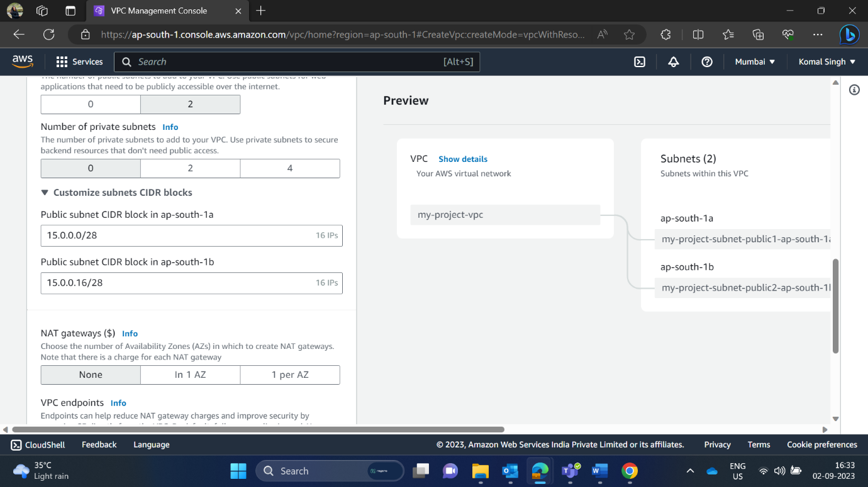

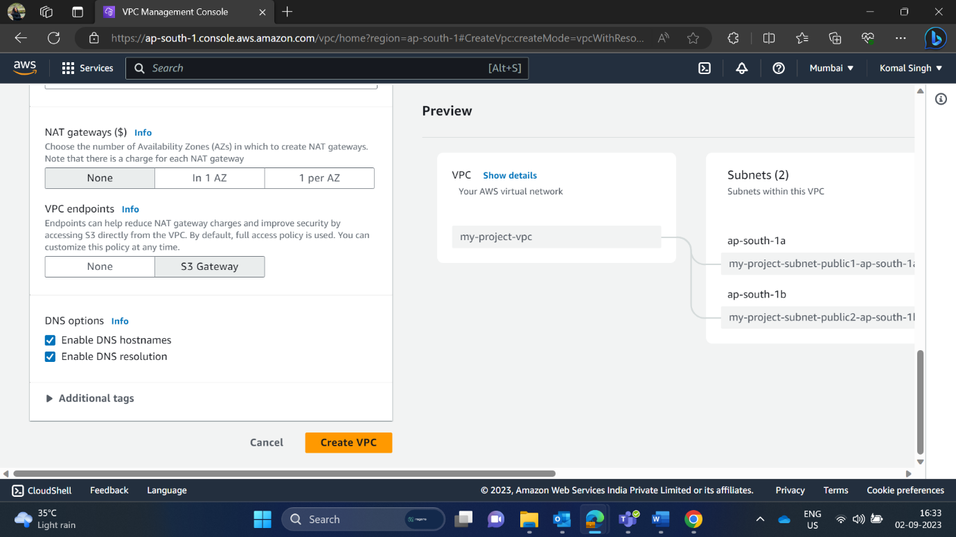

Click on Create VPC

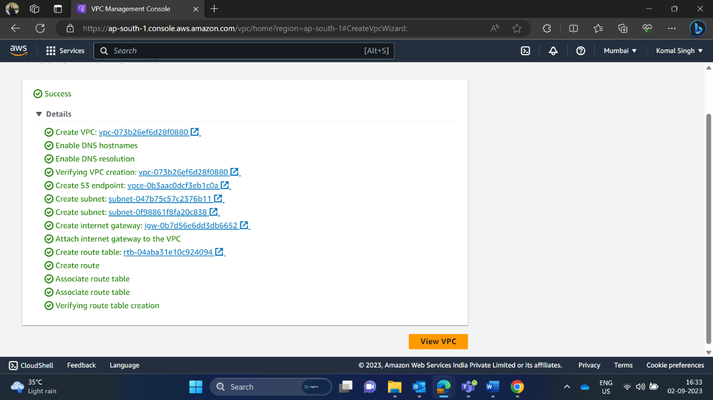

Here, I have successfully created the virtual network with 2 subnets only.

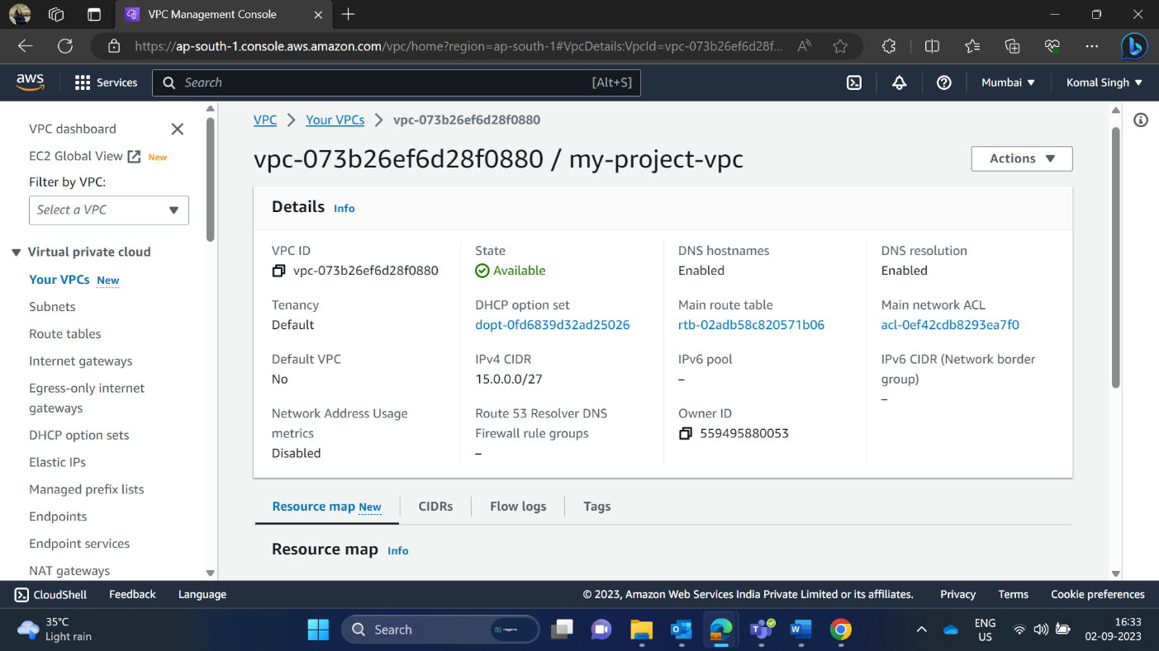

Here, this my 2 subnets of 16 IPs only.

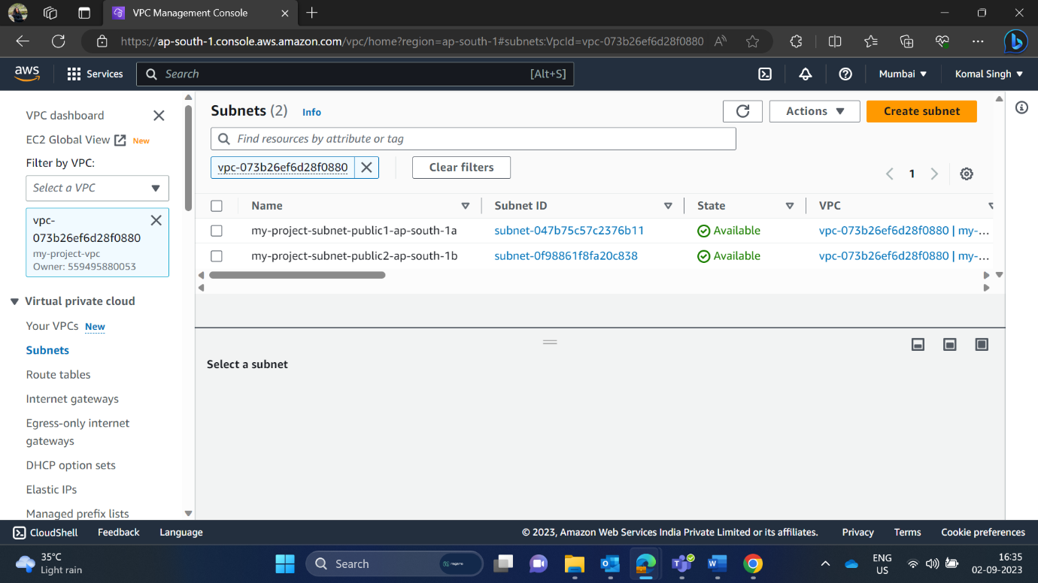

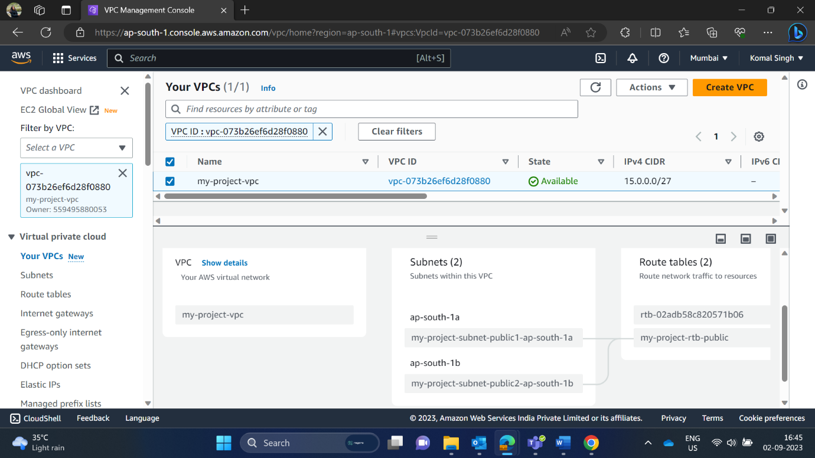

1. **Inside one of the subnets, create a VM and deploy an application code inside it (any existing application created by you before). Make sure to use appropriate NACLs and SGs.**

Search EC2 and click on Launch Instance

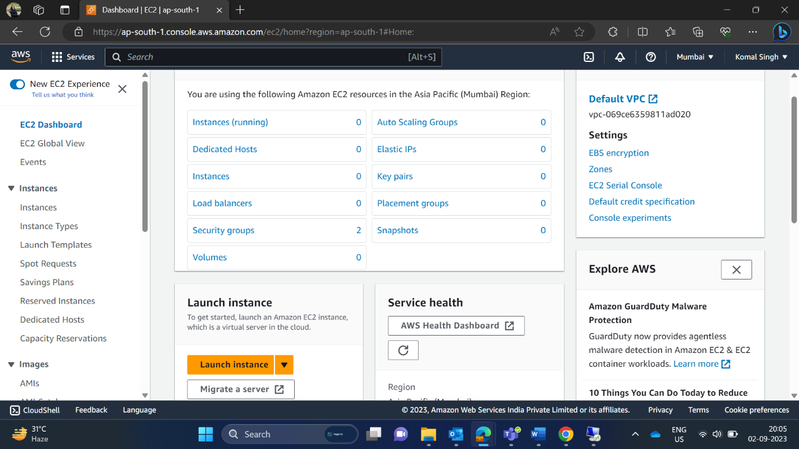

I have given my name as My Project VM

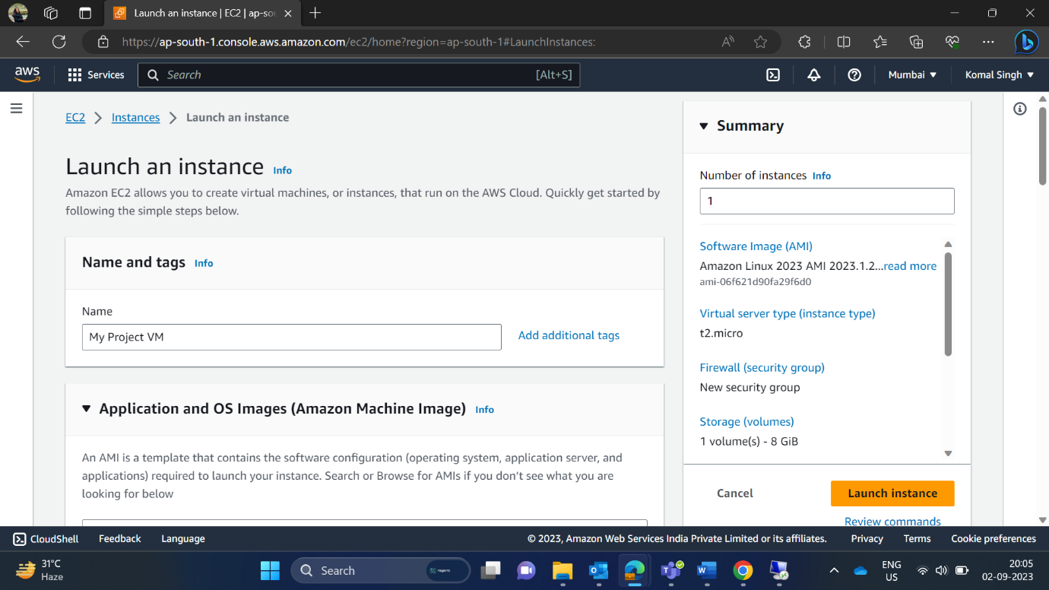

Here, I have chosen Windows for AMI

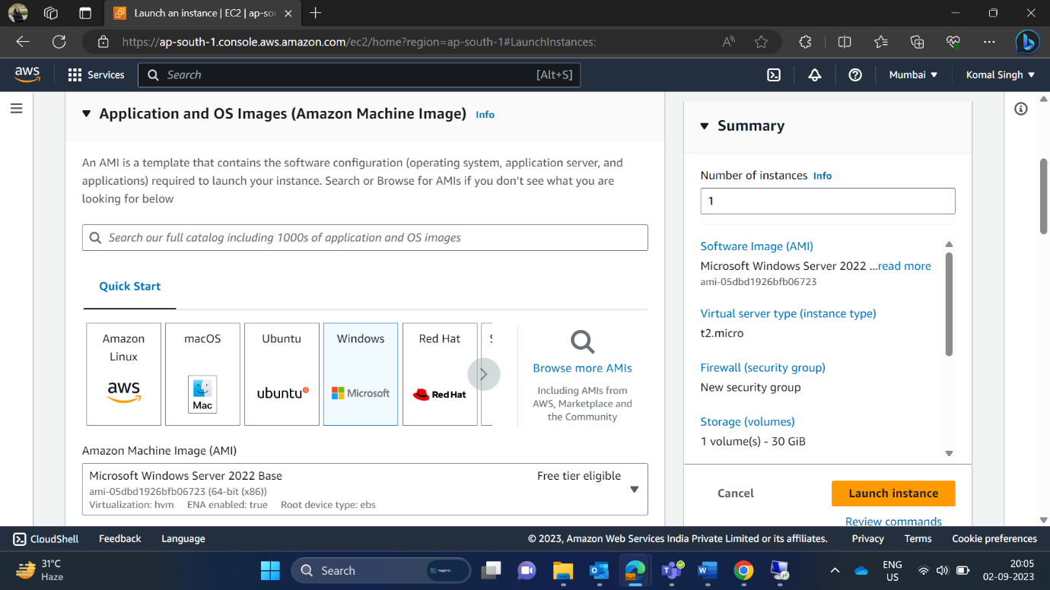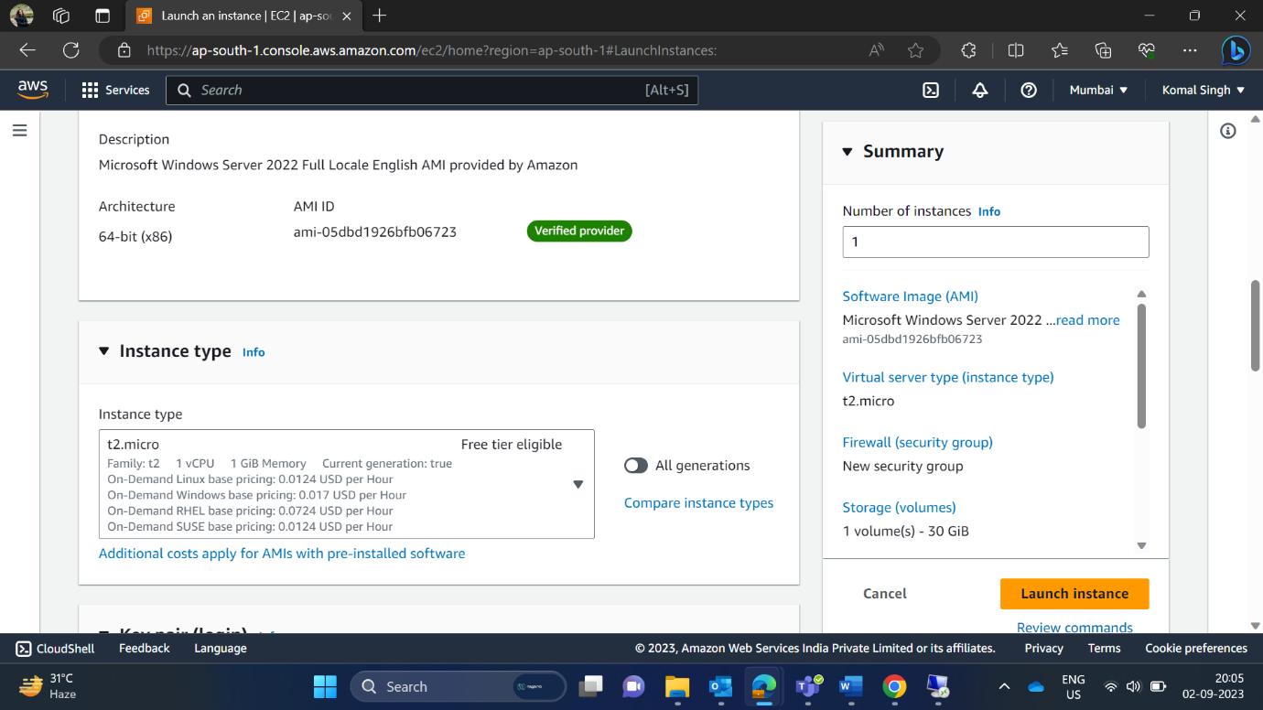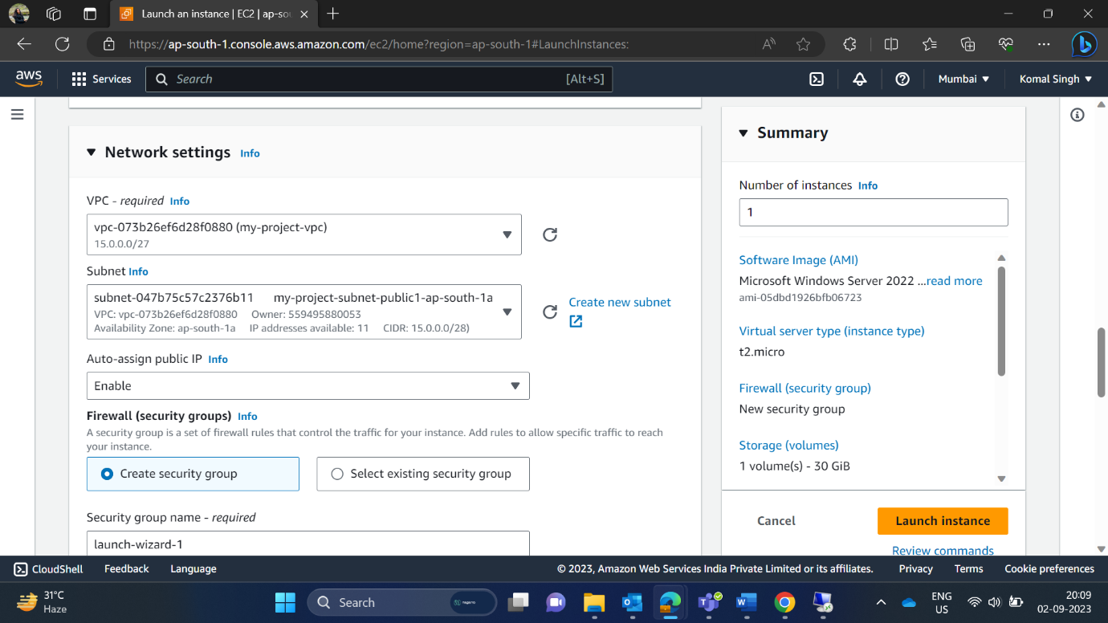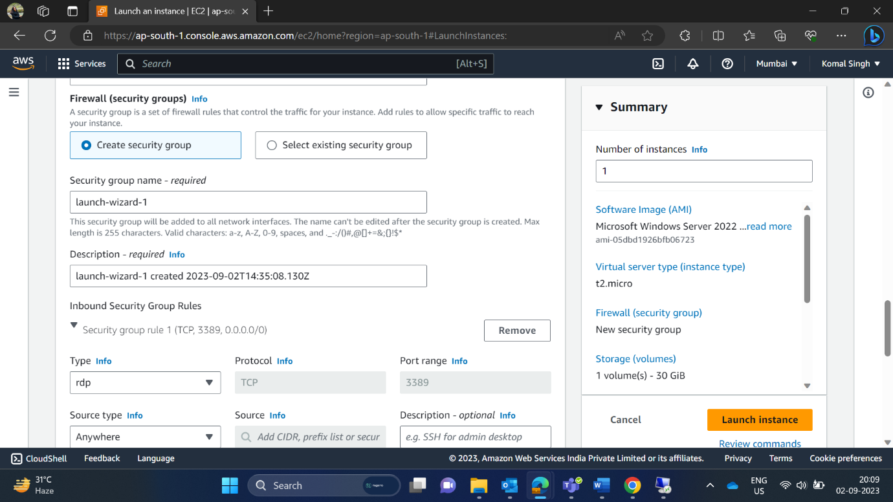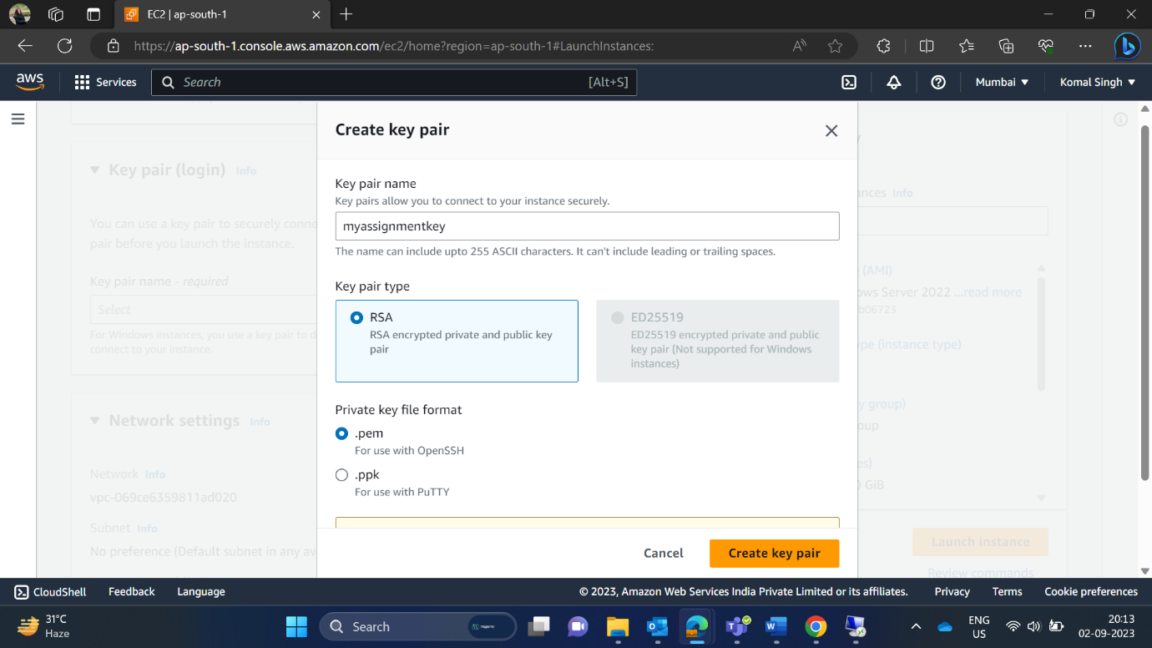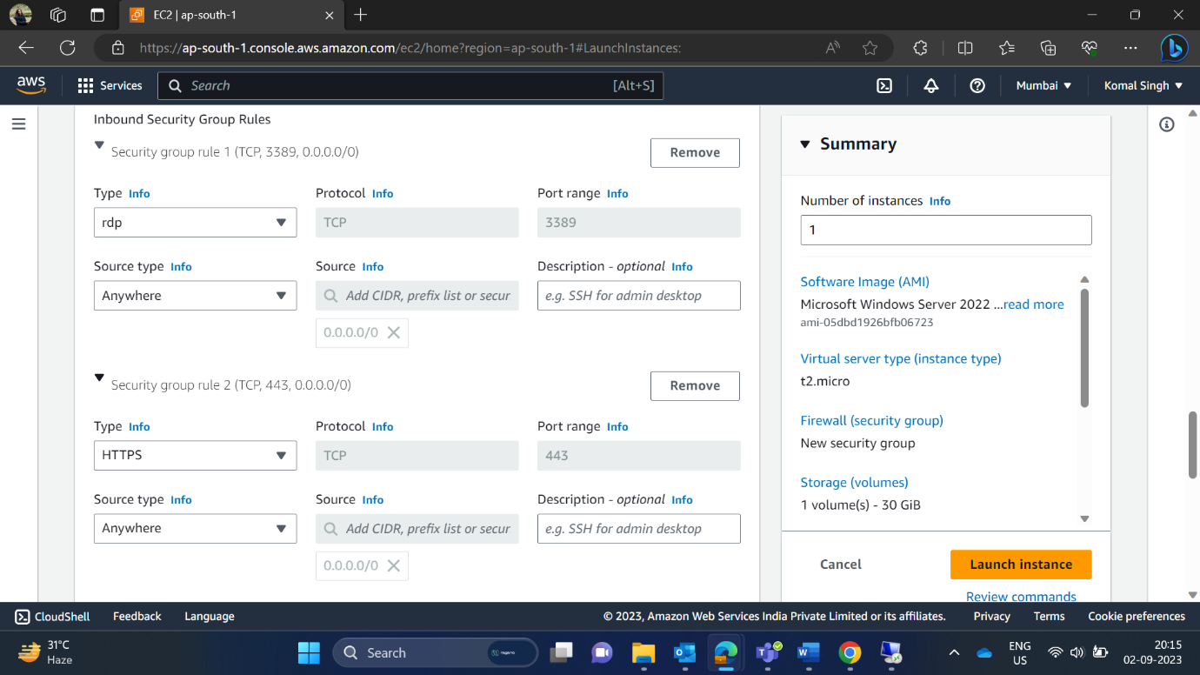

Here, in network setting I have chosen my VPC which I had created “my project” VPC.

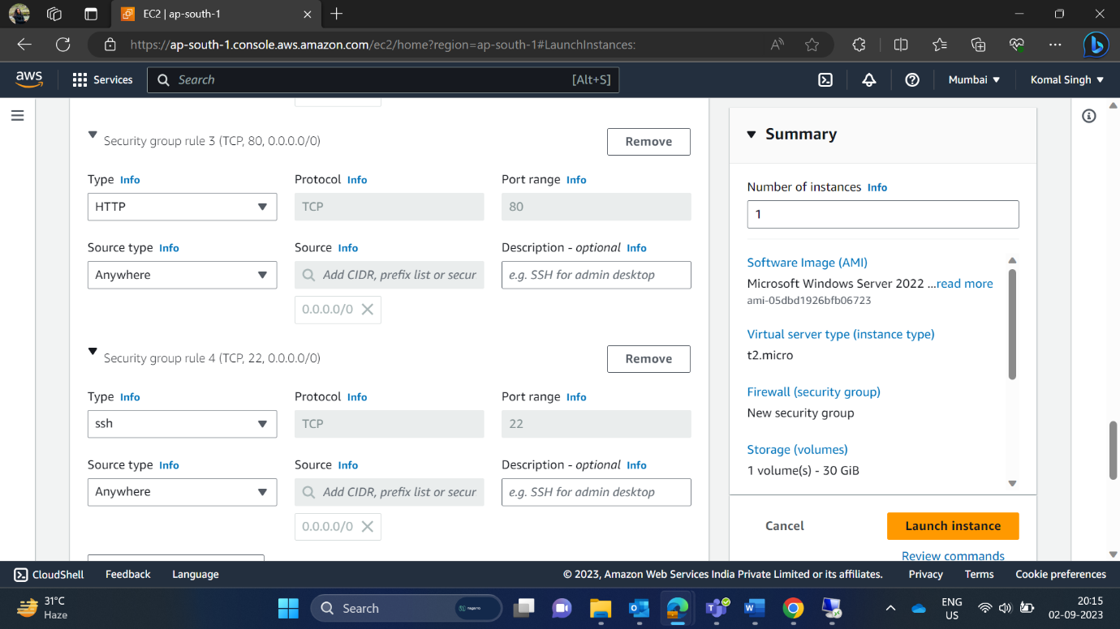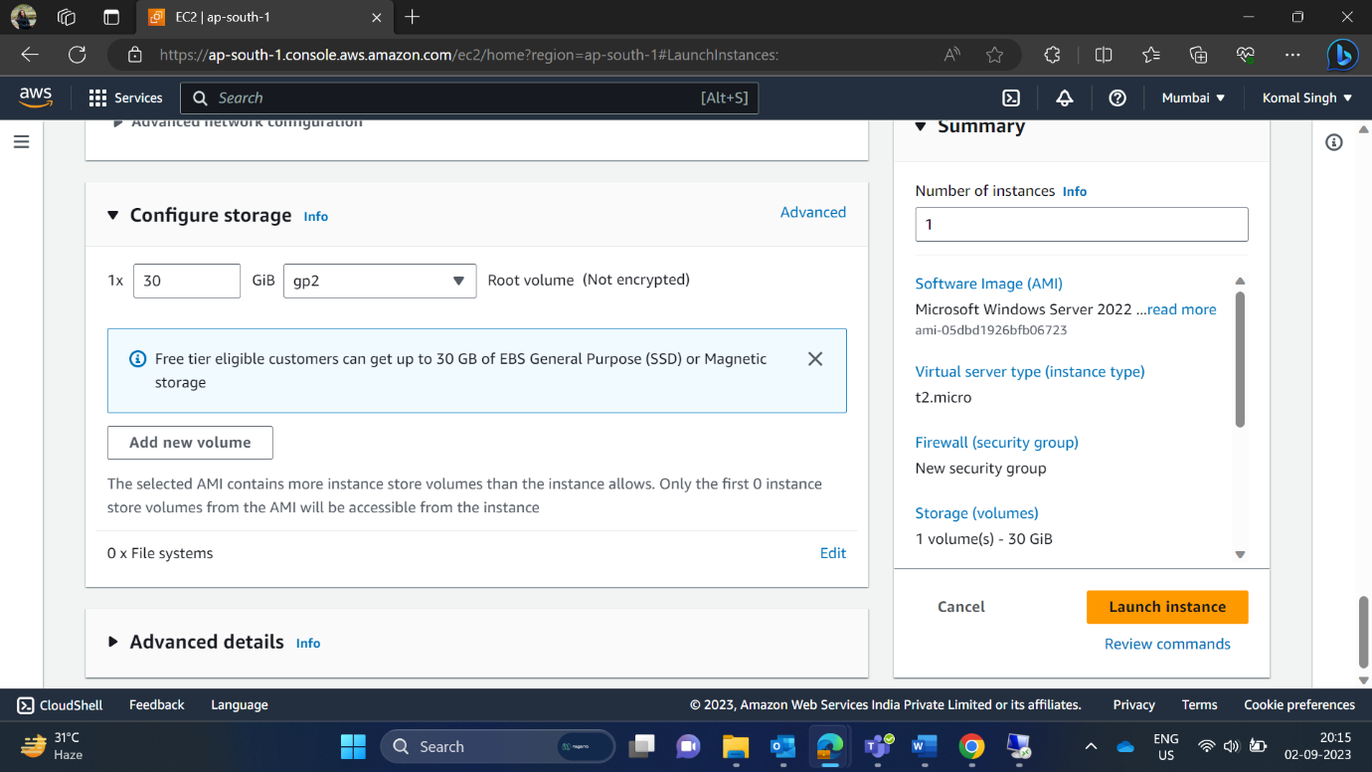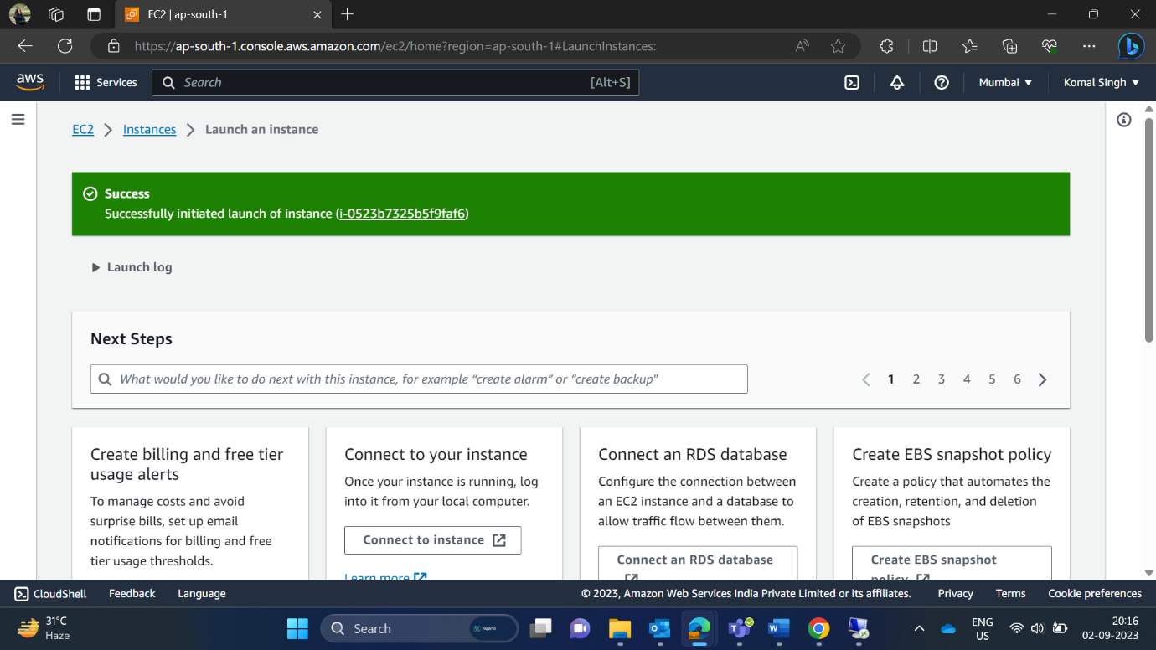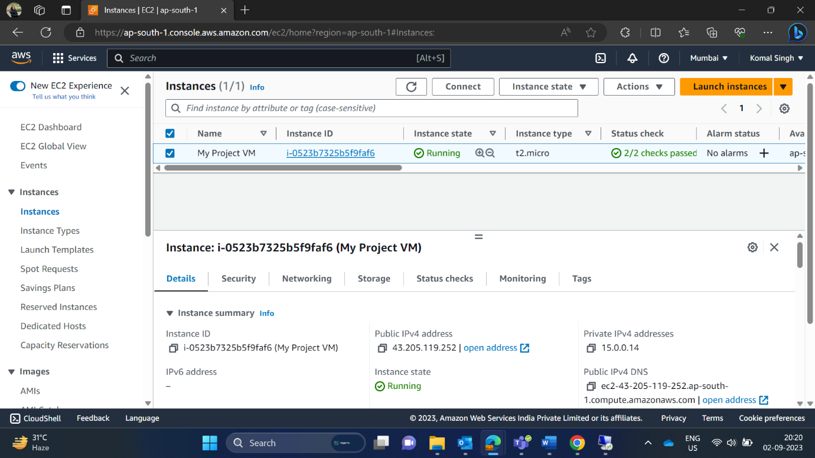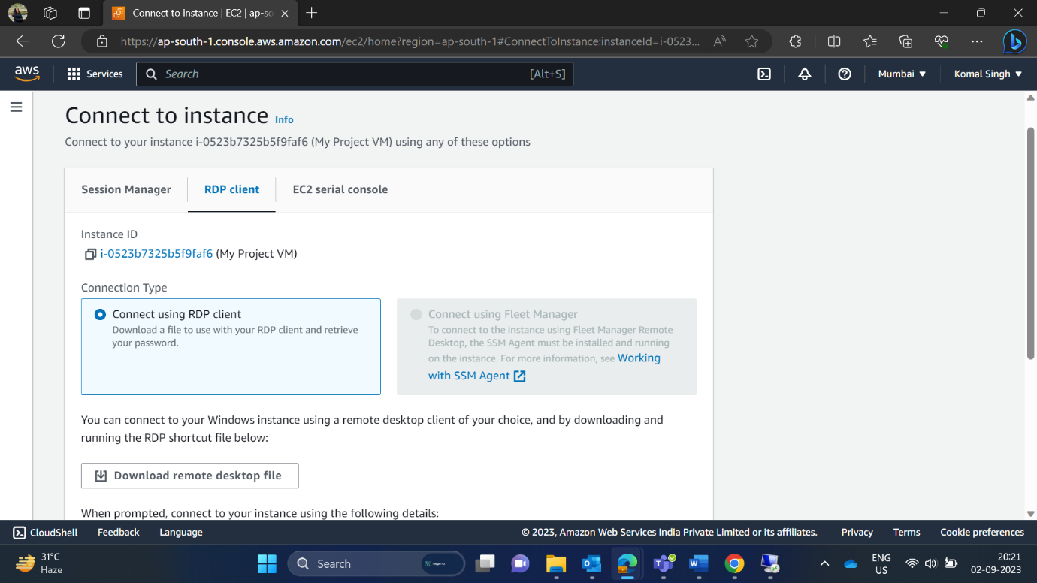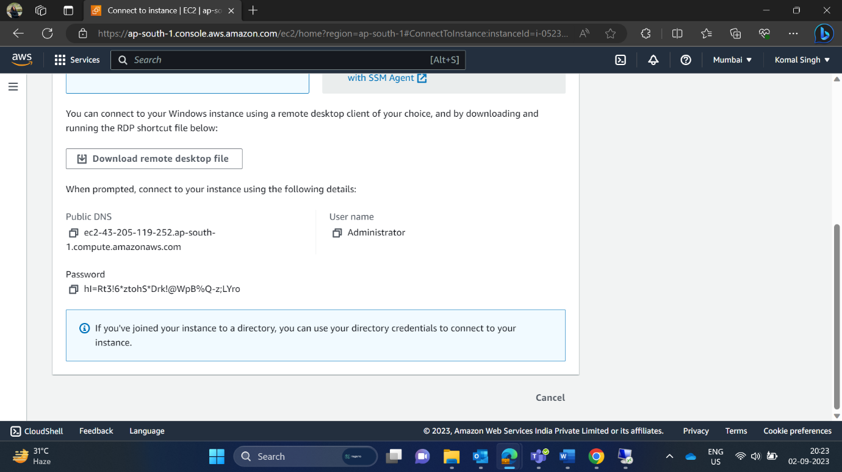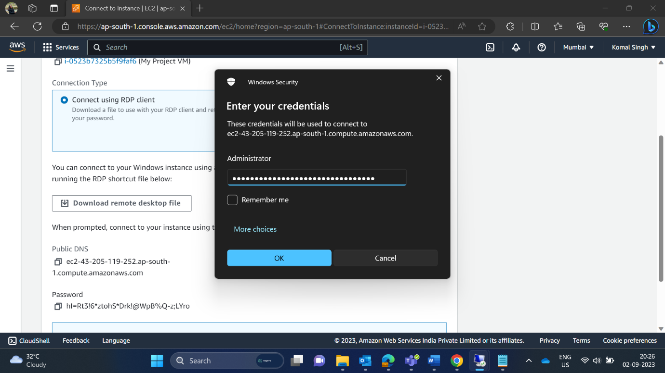

In Security Group, I have allowed source type from anywhere and selected HTTP, HTTPS as I was deploying a web application.

I have also configured storage.

After all the inputs, I have successfully created a VM. Now, click on connect.

After, clicking on connect button here an interface appears. Choose RDP client and decrypt the password. After decrypting the password, a username “Administrator” and password come.

Use Remote Desktop Connection and enter credentials.

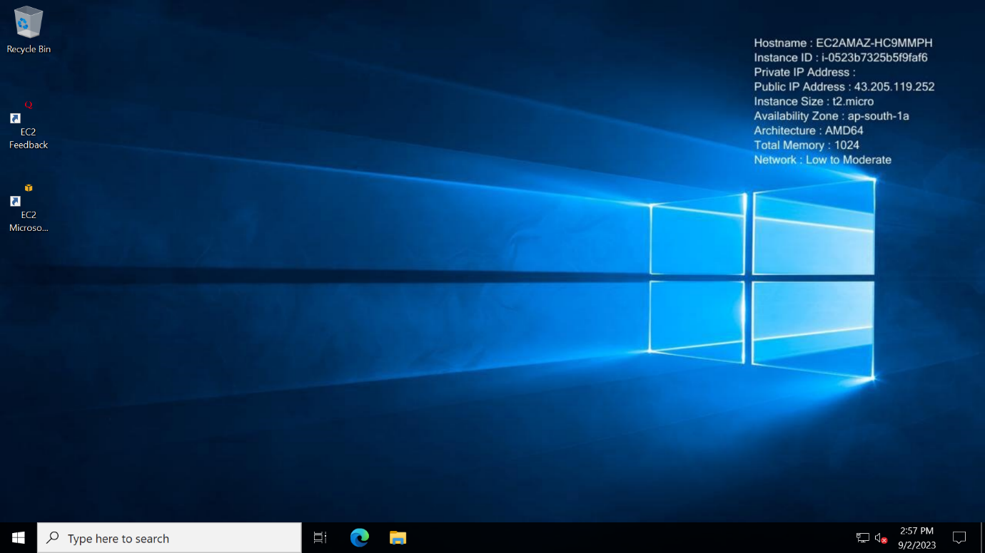

Here, I have successfully opened my virtual machine.

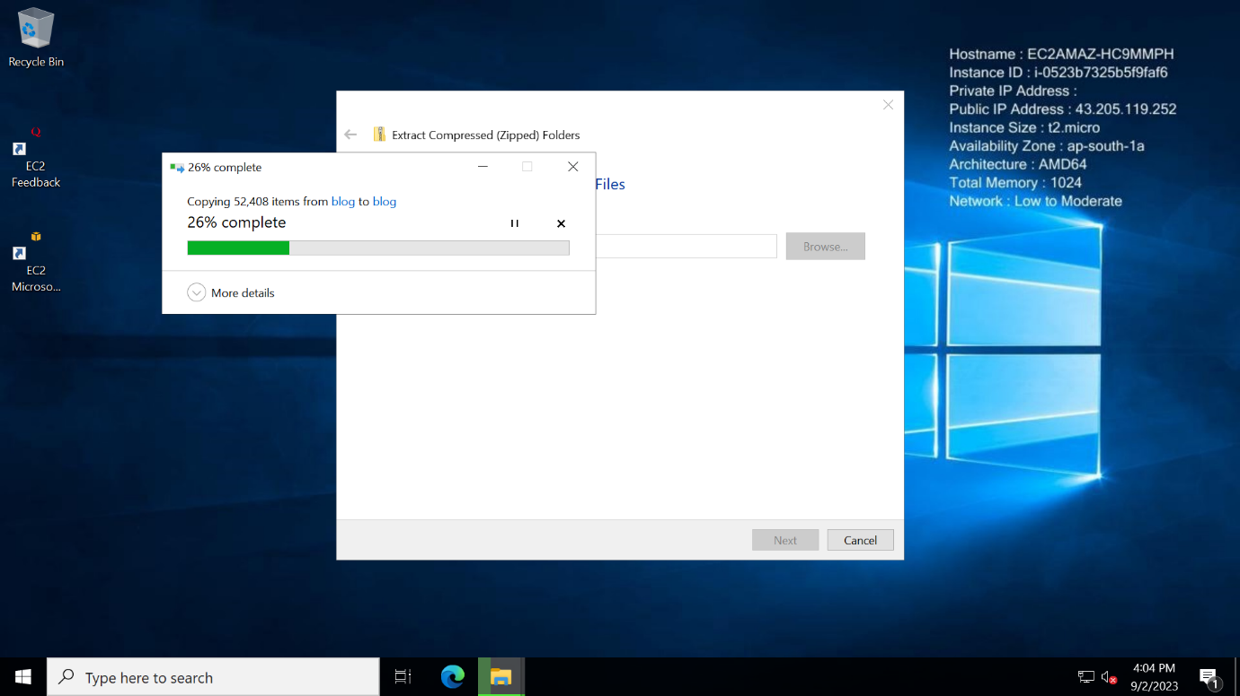

Here, I am extracting my web application.

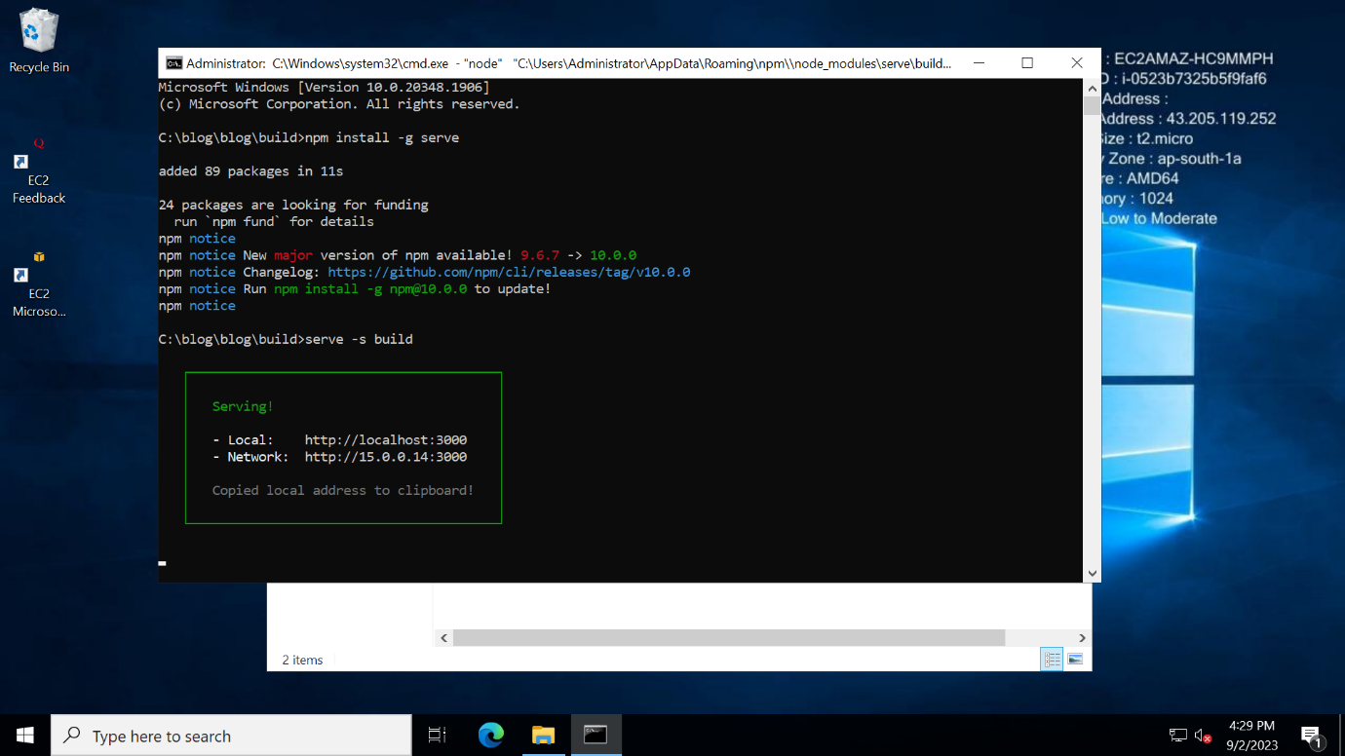

After building successfully, my application is running on Network: <http://15.0.0.14:3000> and on local it is running on <http://localhost:3000> .

1. **Deploy the same application to Elastic beanstalk Service.**

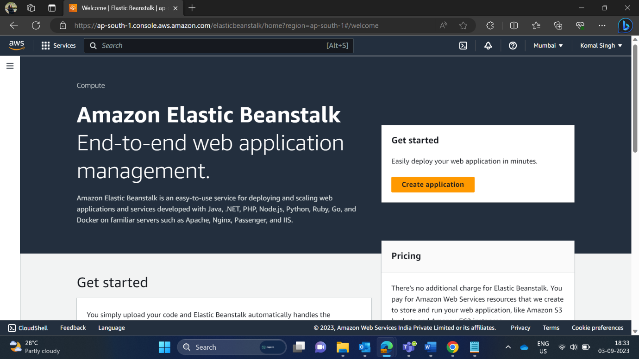

Search elastic beanstalk and click on create application. Inside environment we need a role for which first need create it on IAM. Search IAM and there choose AWSElasticBeanstalkWebTier.

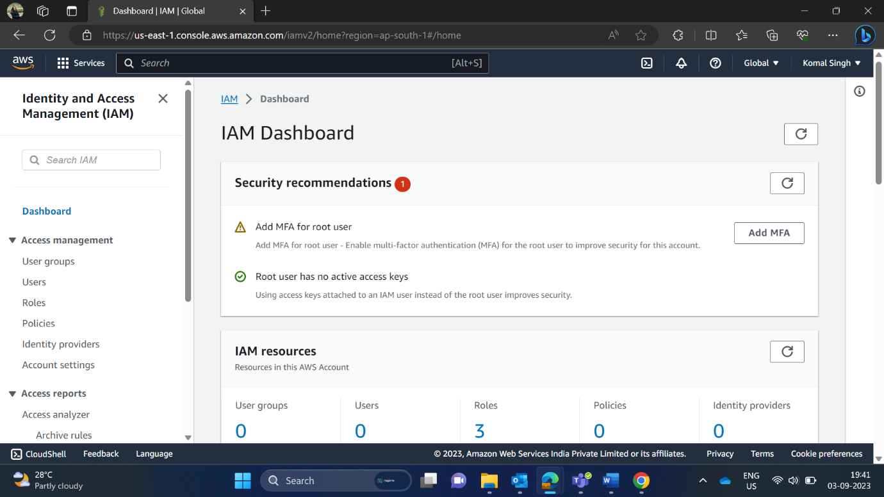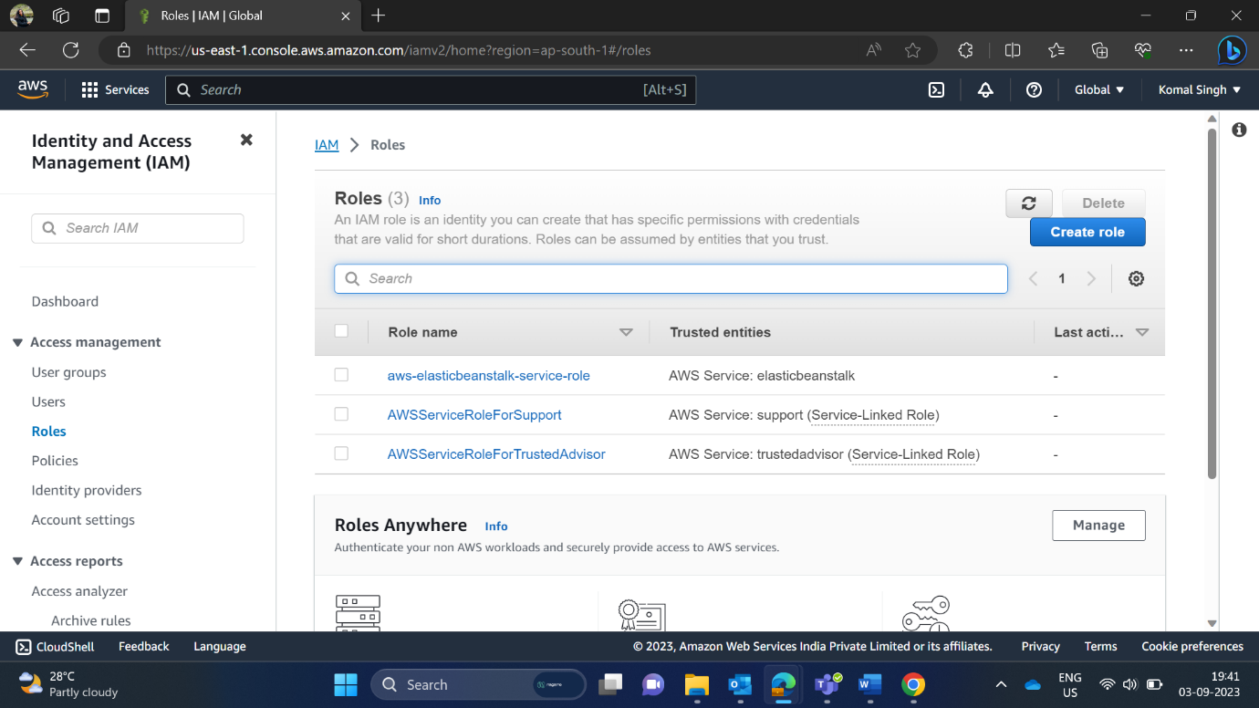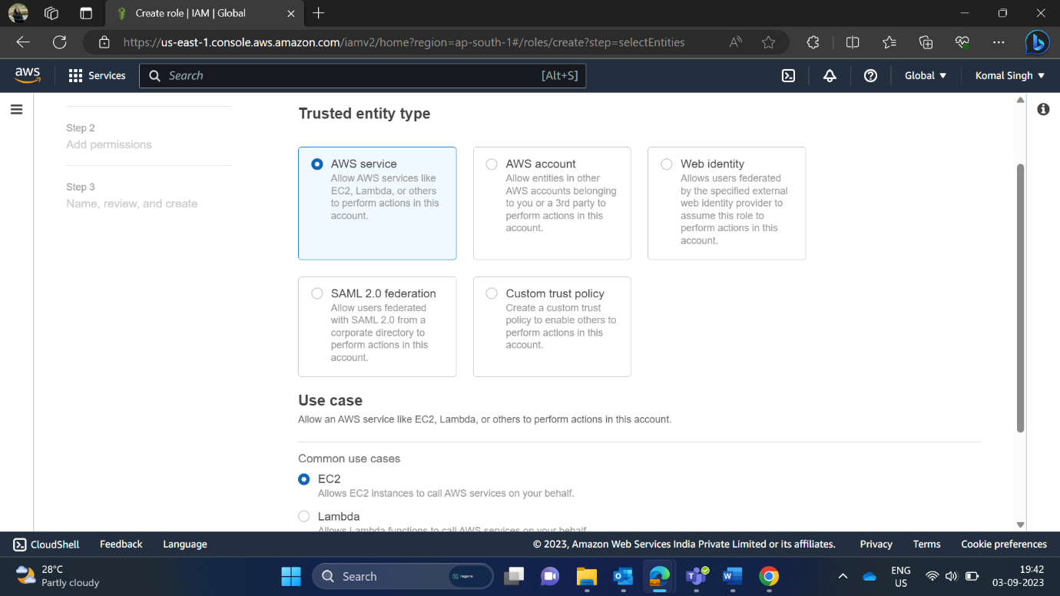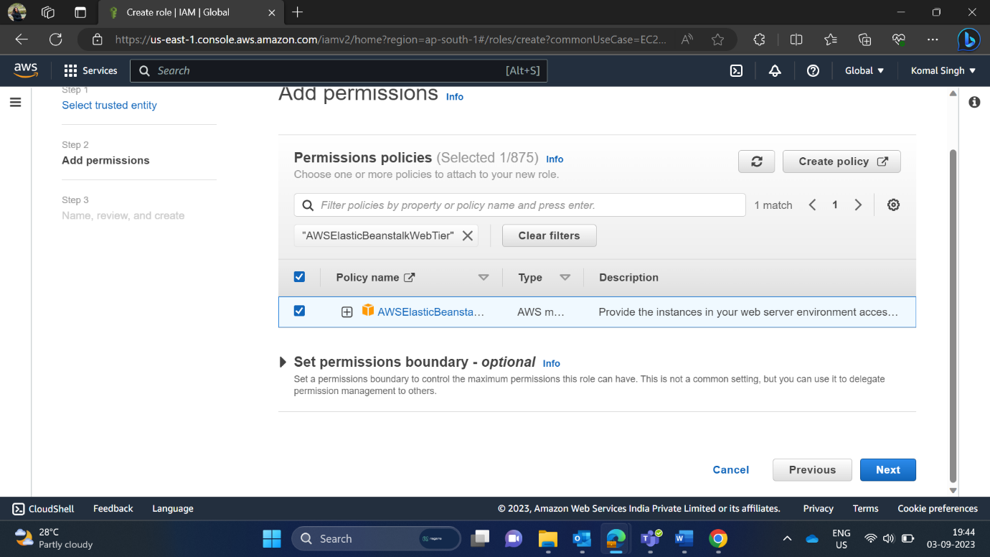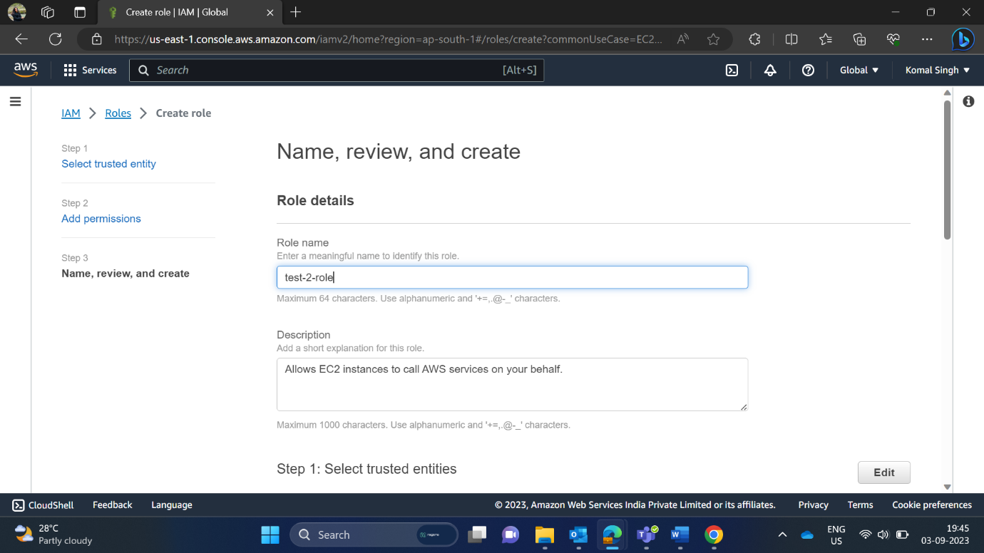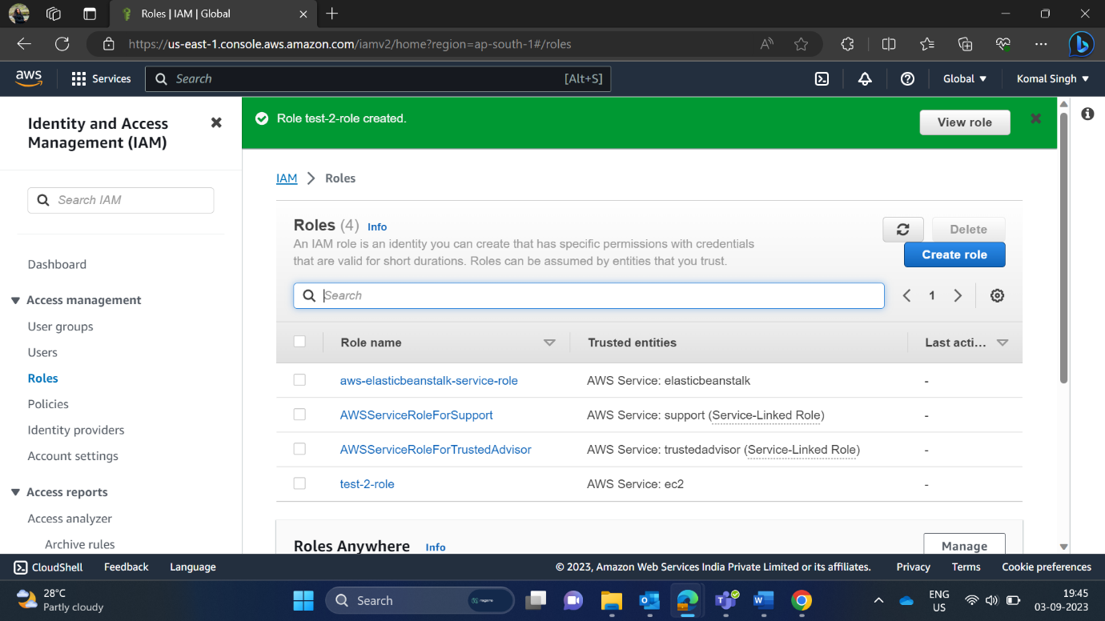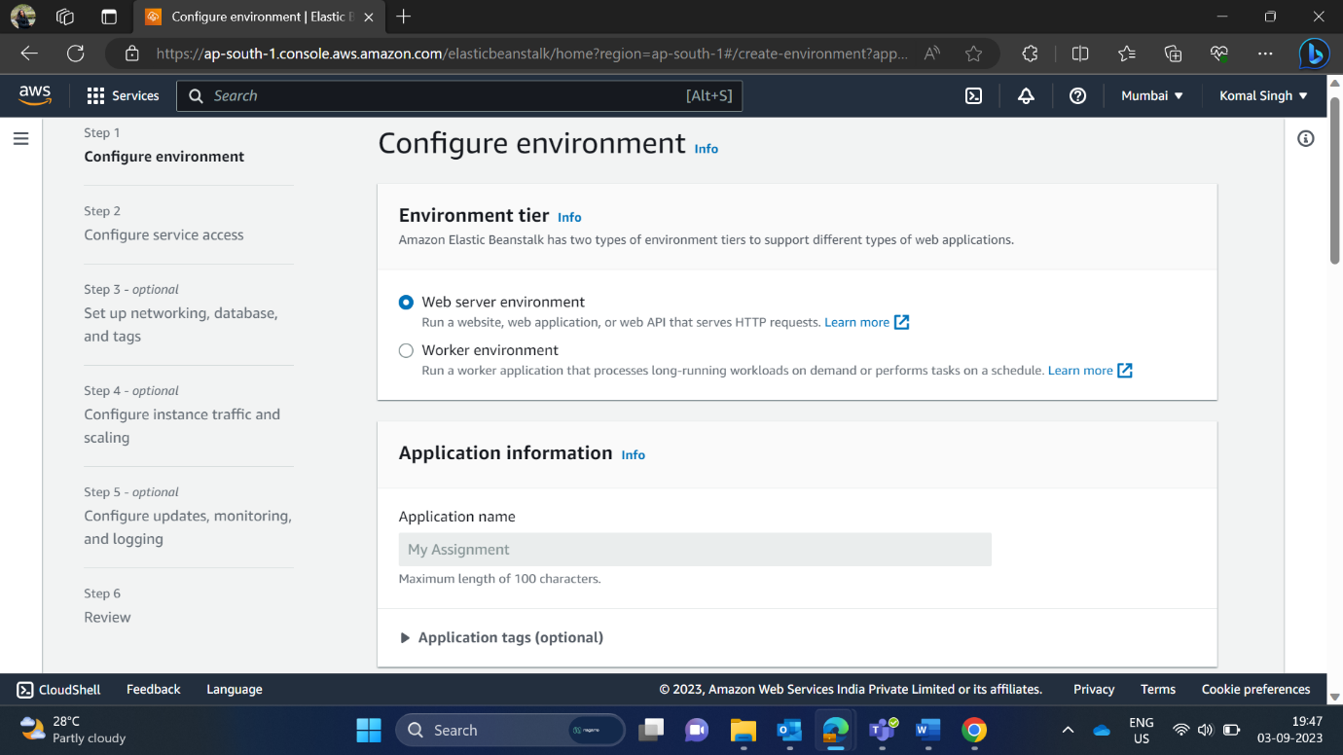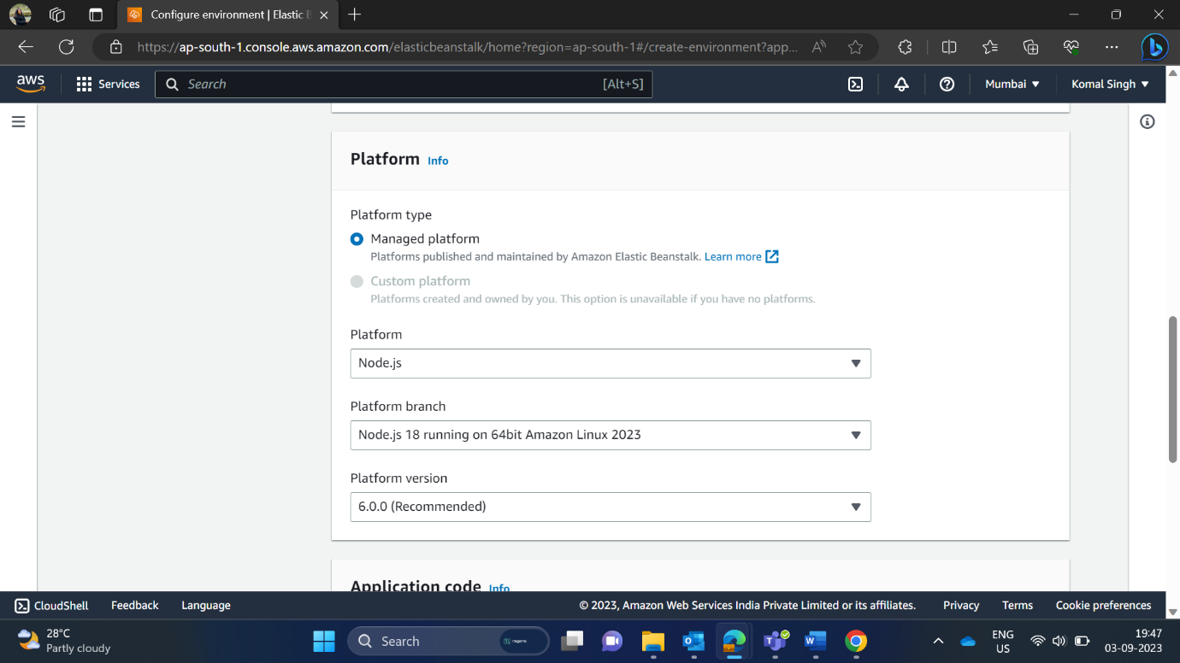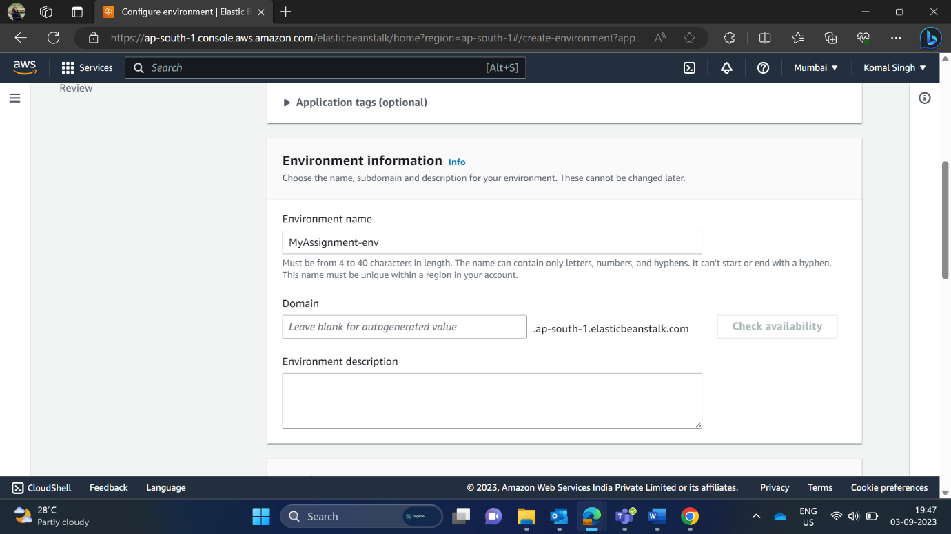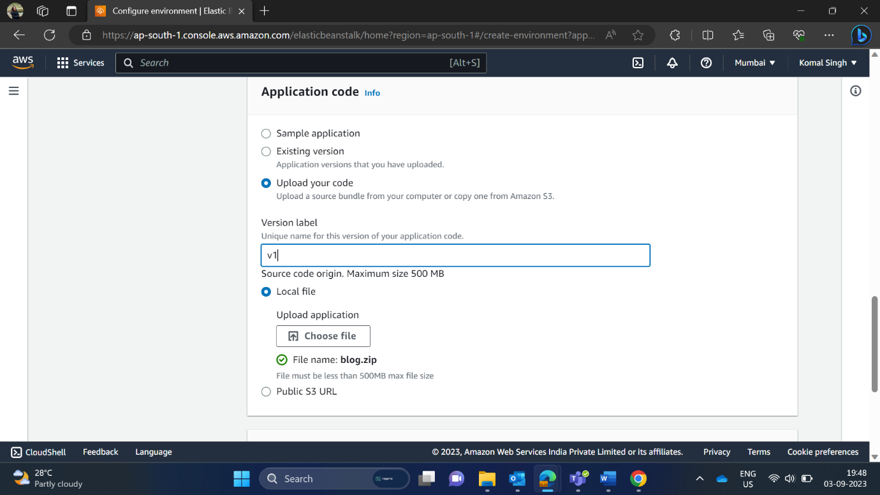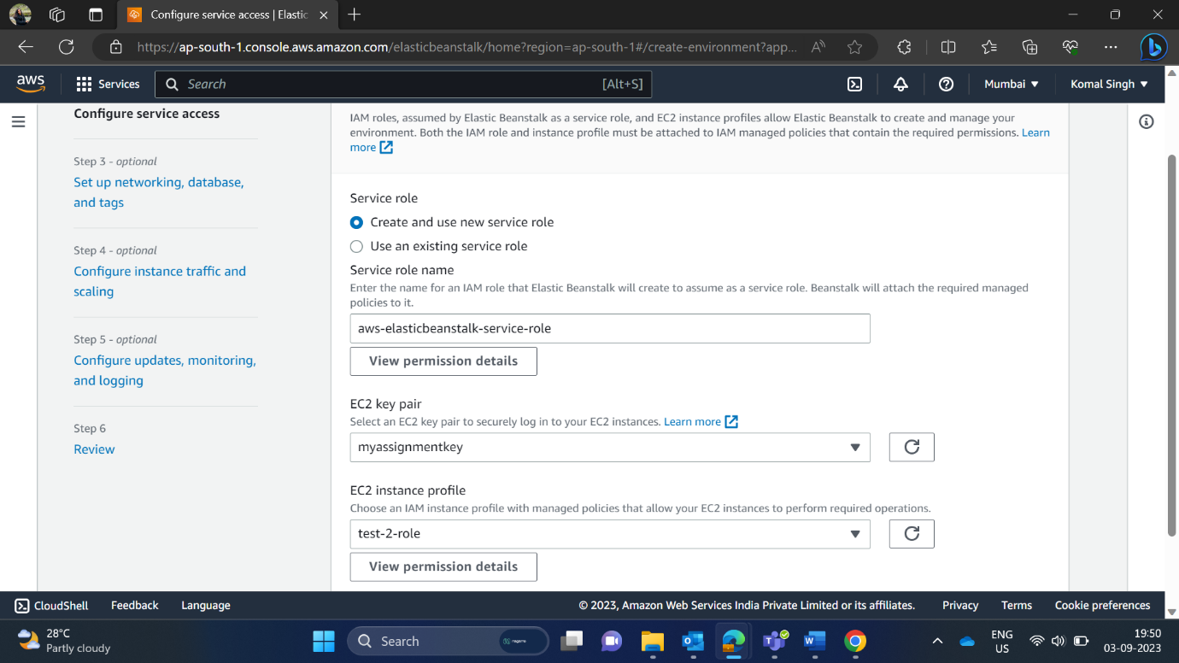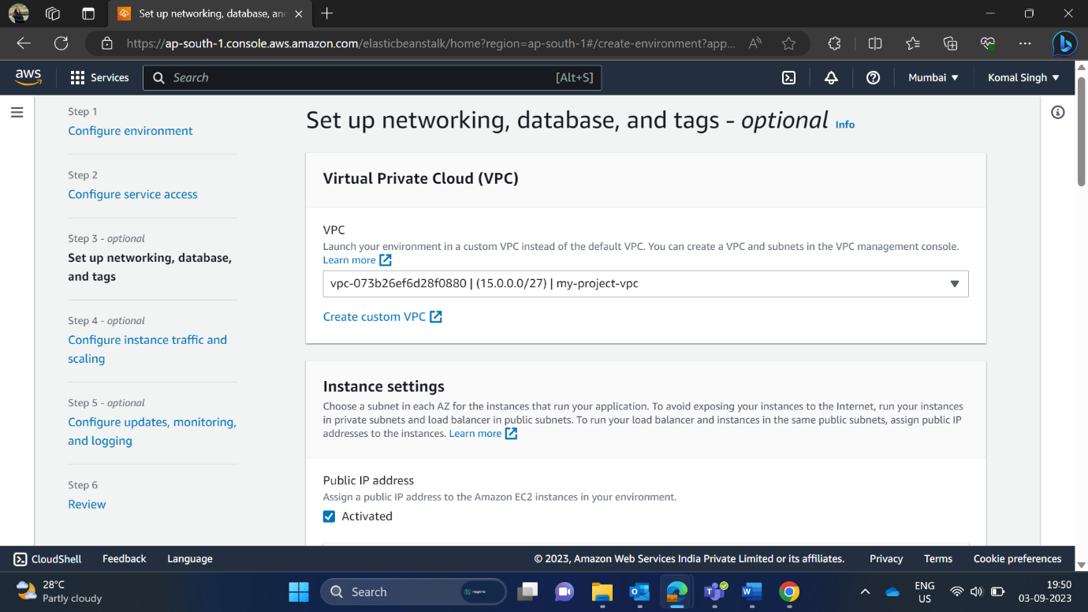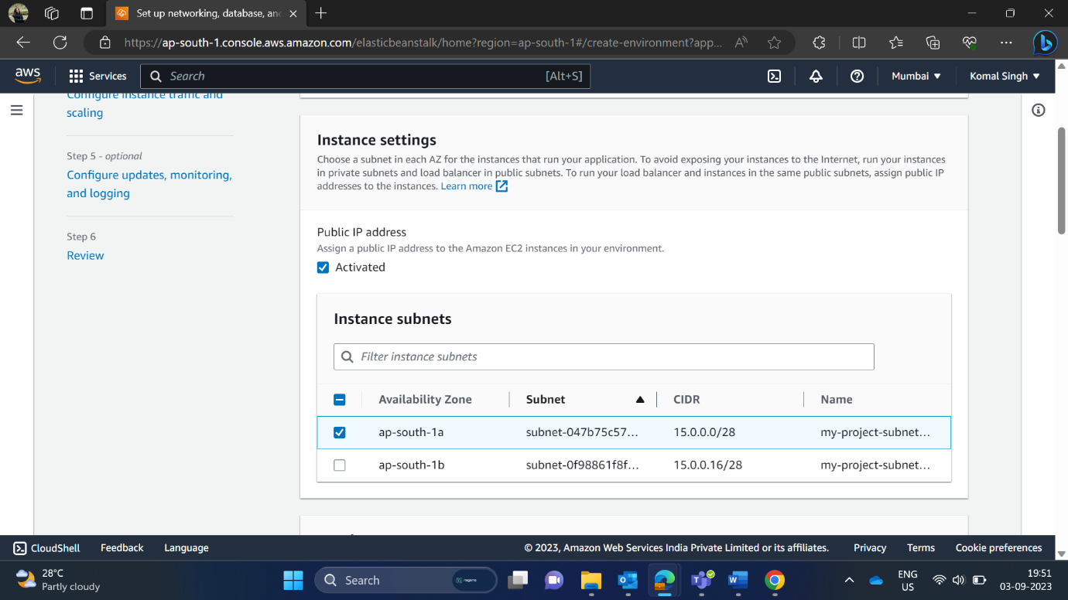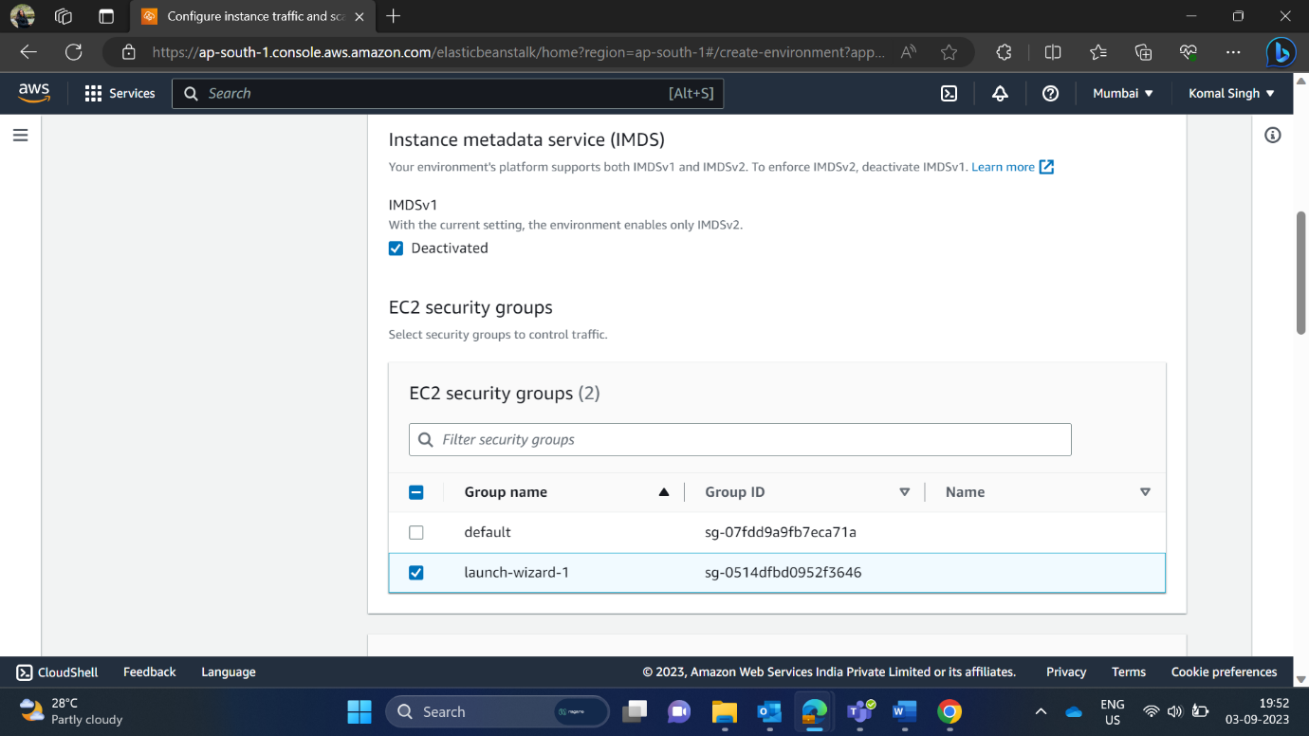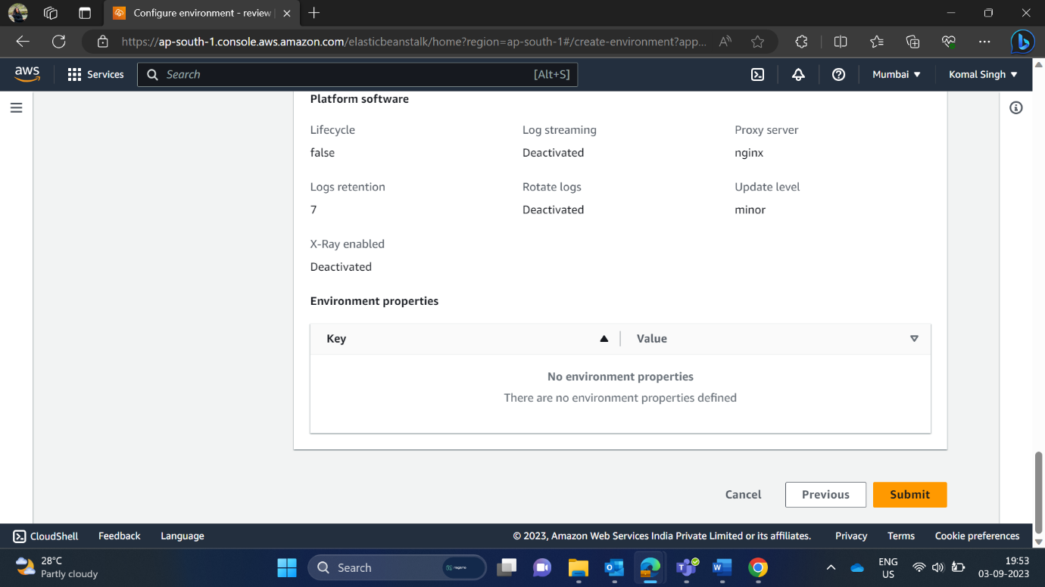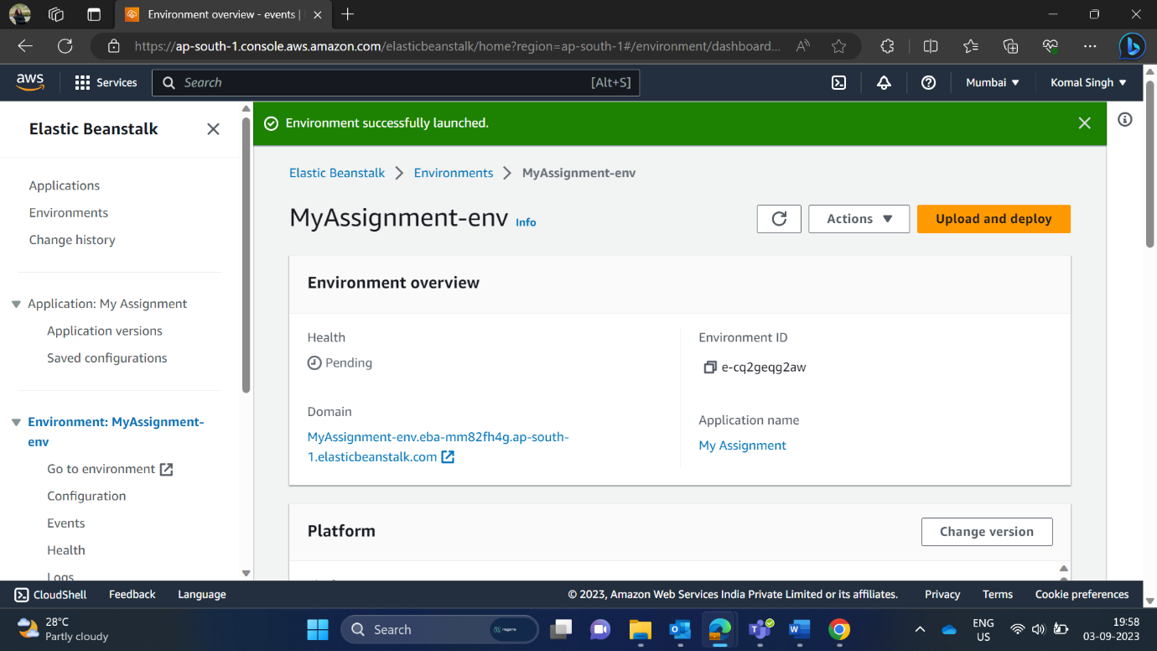

Here, I have successfully created the IAM, and name is test-2-role.

In platform, I have selected Node.js because I’m deploying a react application.

Now, I’m uploading my existing code under application code column.

In Service role, I have chosen my existing EC2 key pair and choose EC2 instance profile, which I have created on IAM.

Chosen the instance subnet and EC2 security group.

After clicking on submit, my environment has successfully launched, and I got my Domain.

1. **Create a Lambda that should trigger as soon as you upload a file in the S3 bucket. Function should be able to print the name of the file uploaded in the function.**

First, I have created a S3 bucket. Search S3.

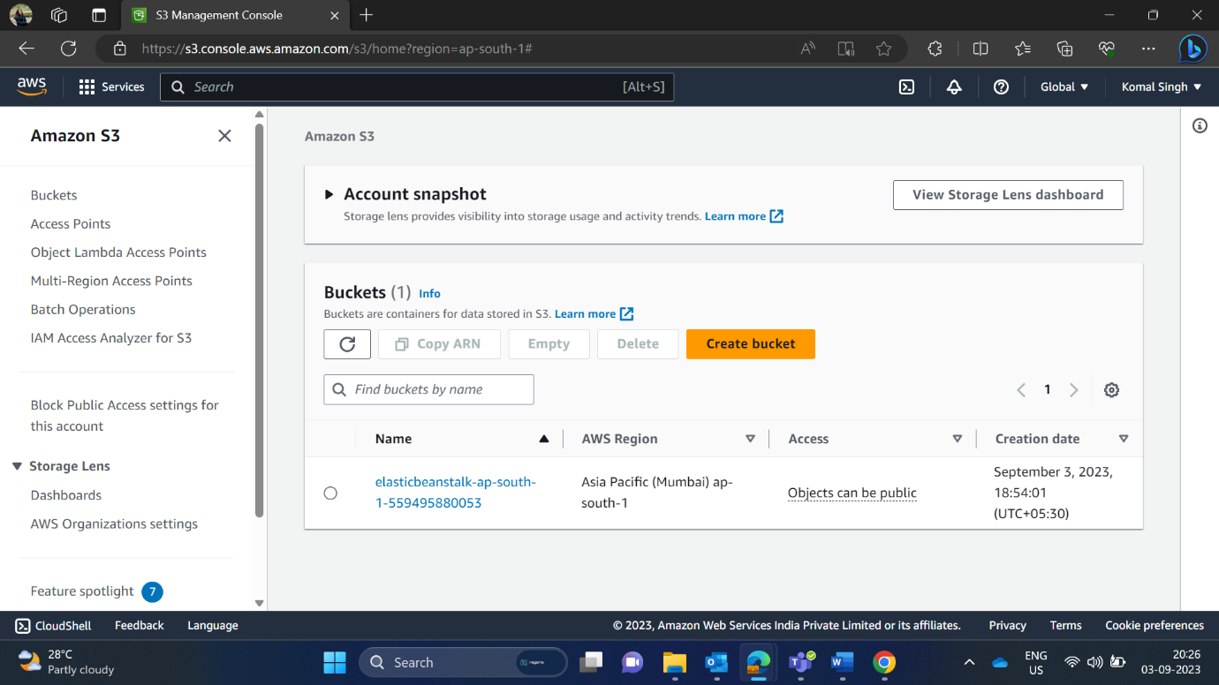

My bucket name is lambda-trigger-s3-bucketfunc.

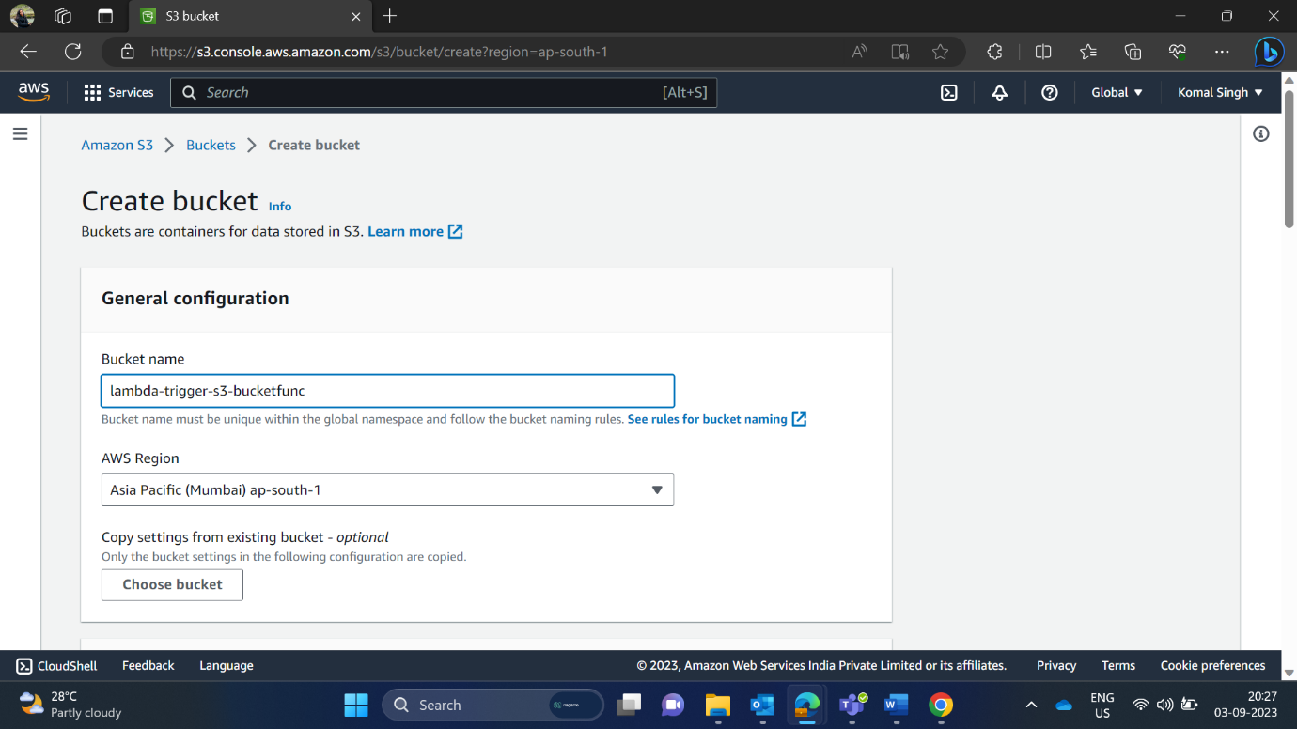

Click on Create Bucket. 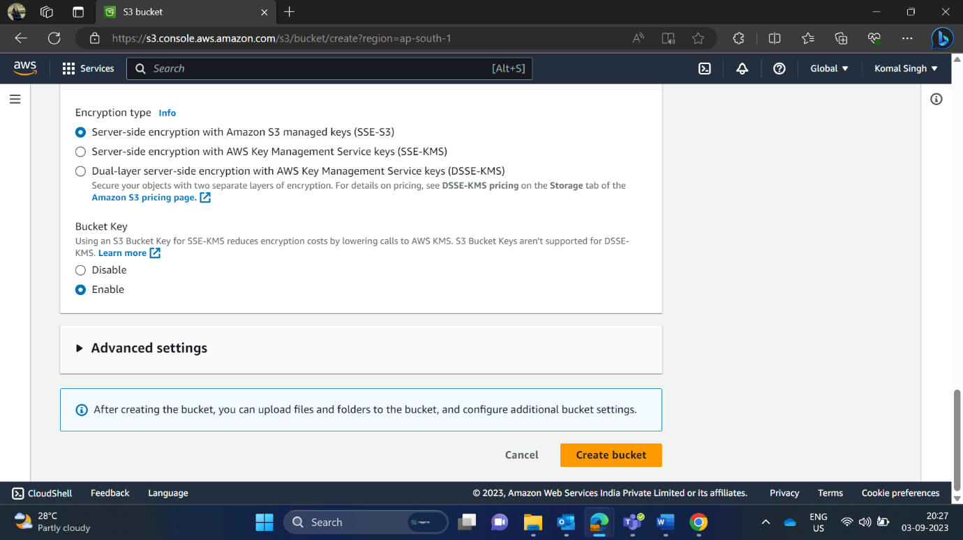

Here, I have successfully created a bucket.

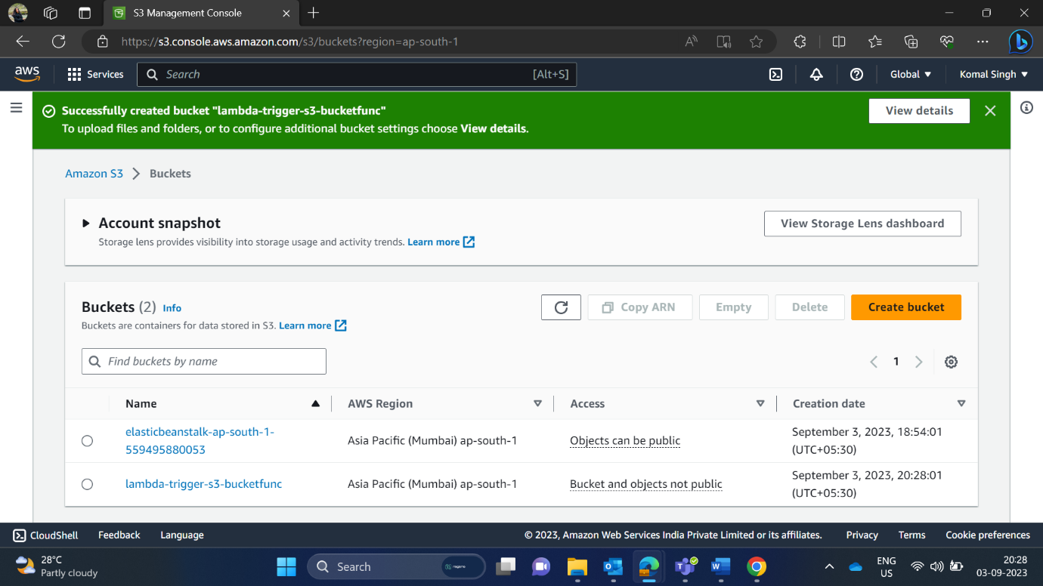

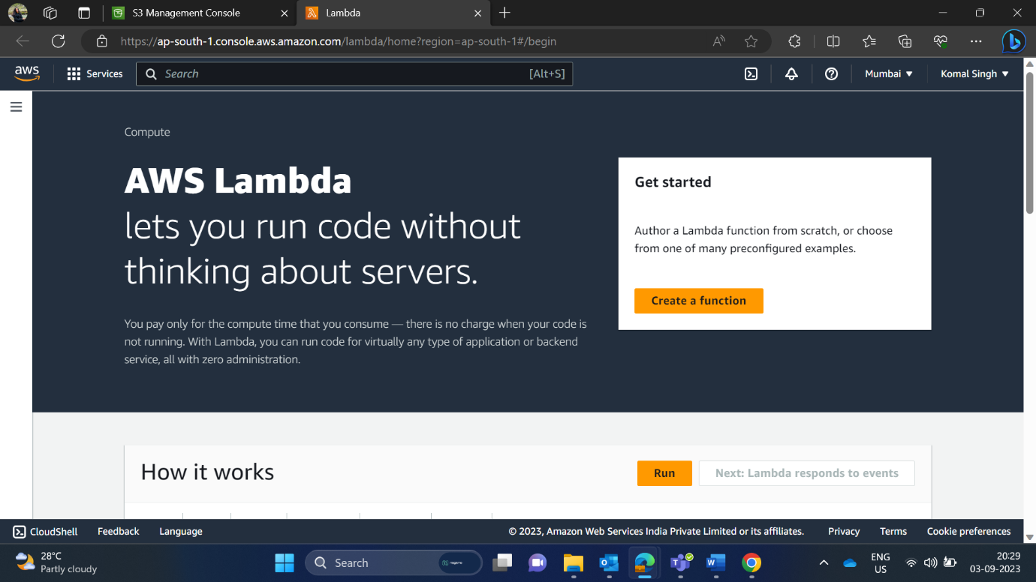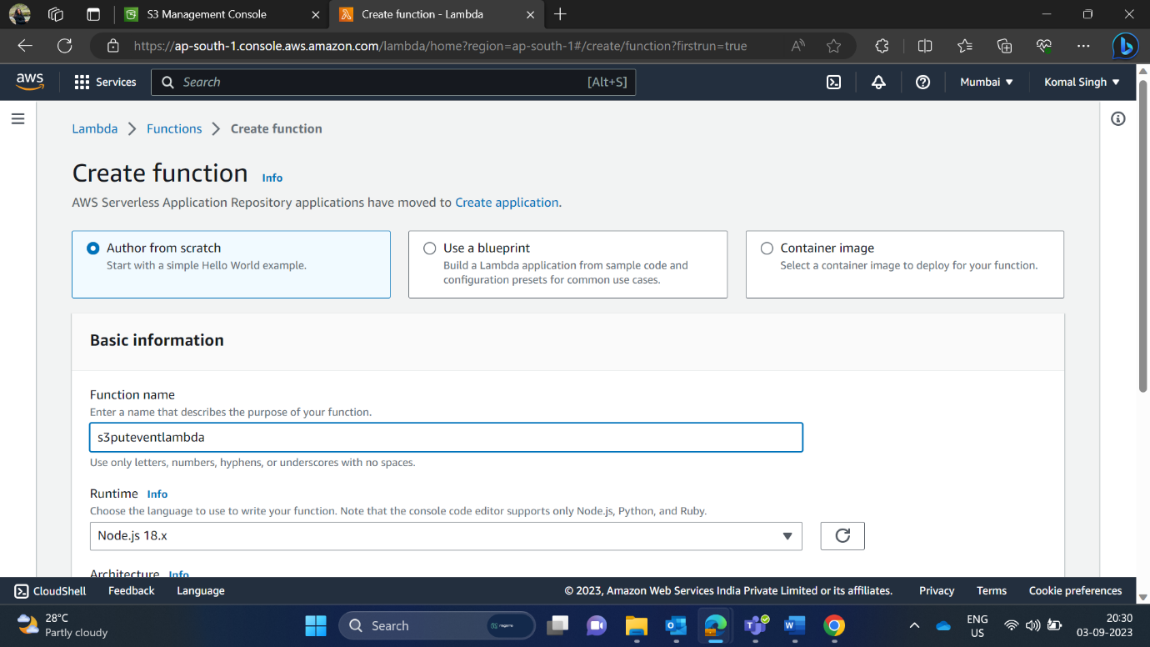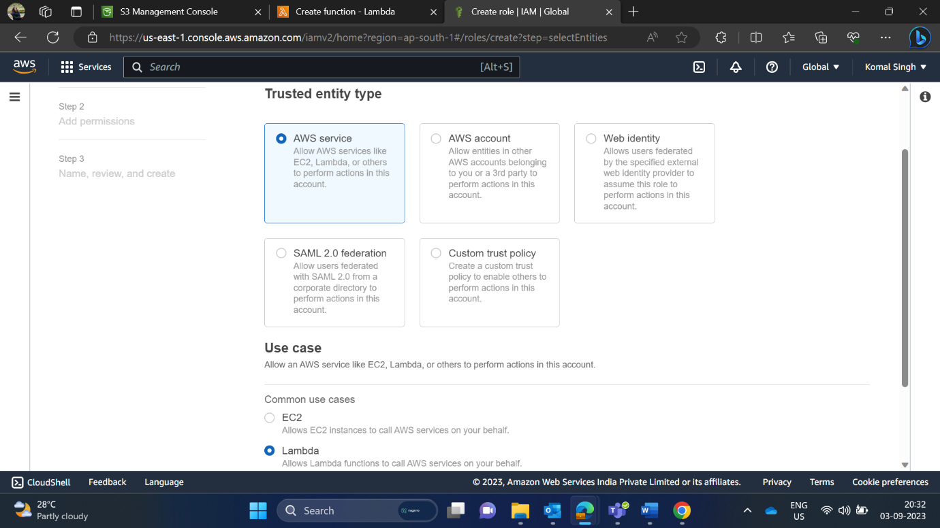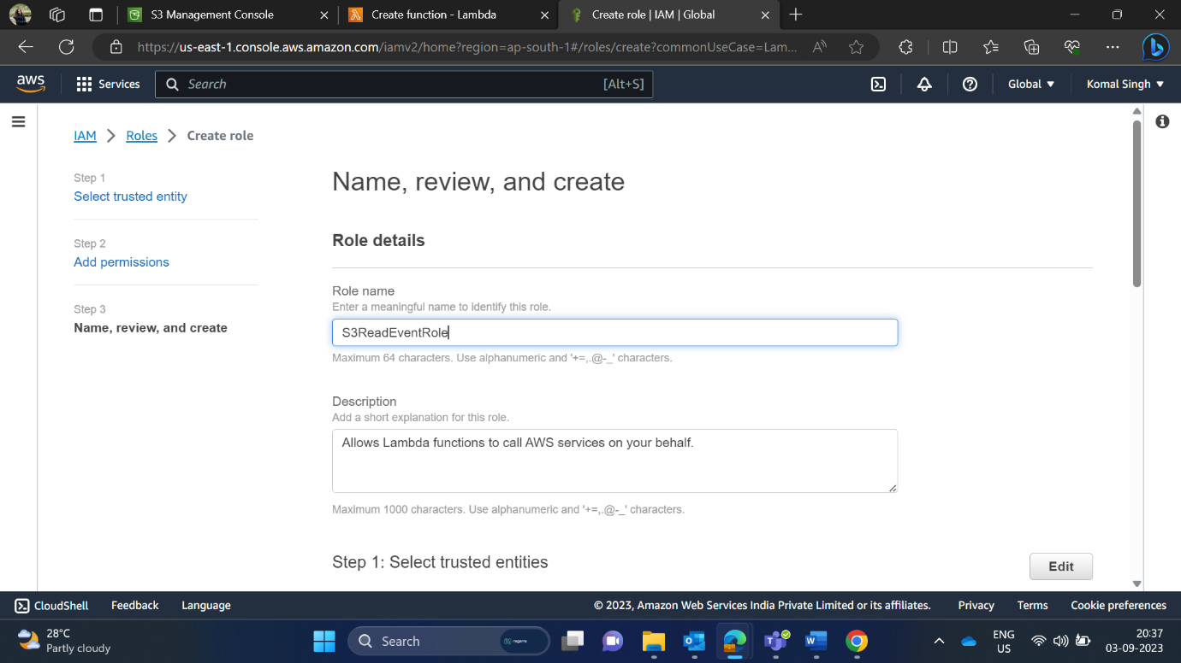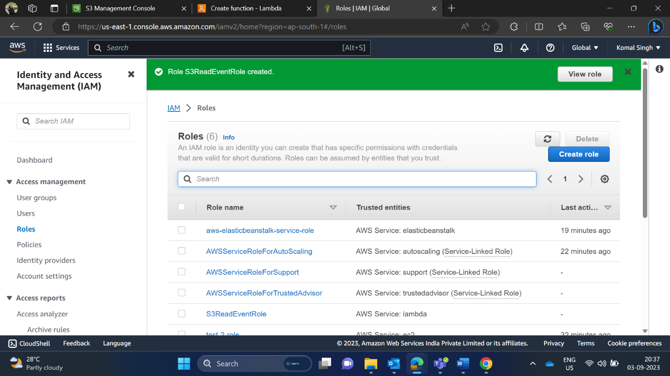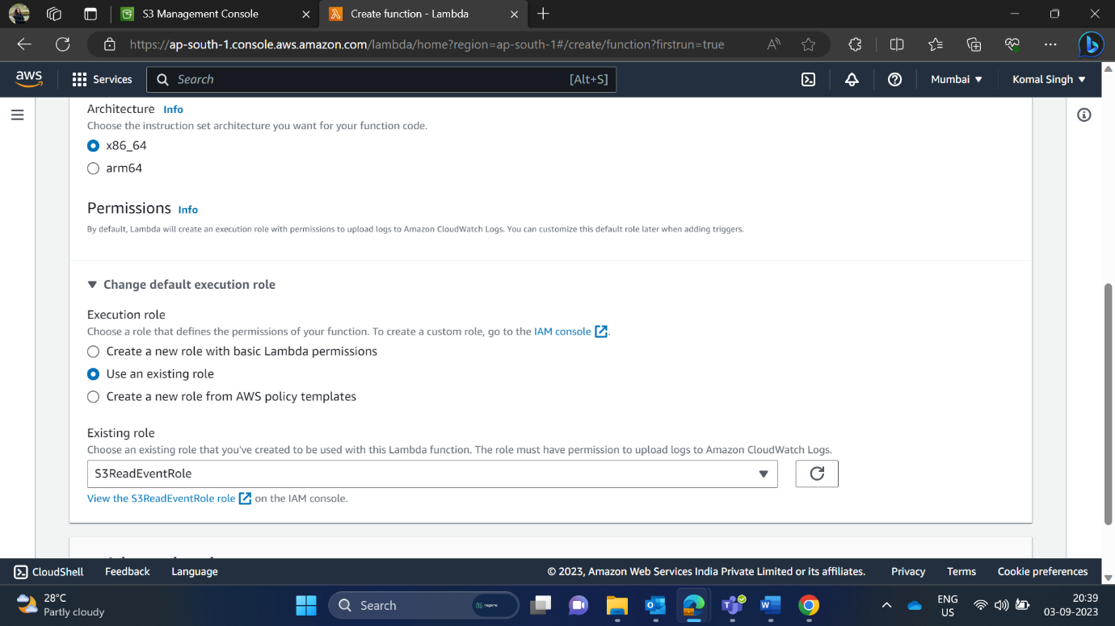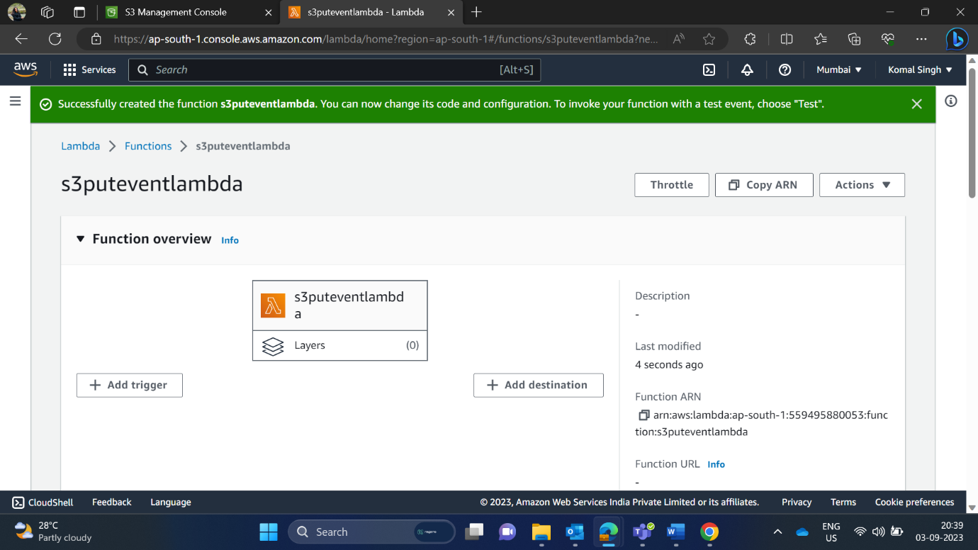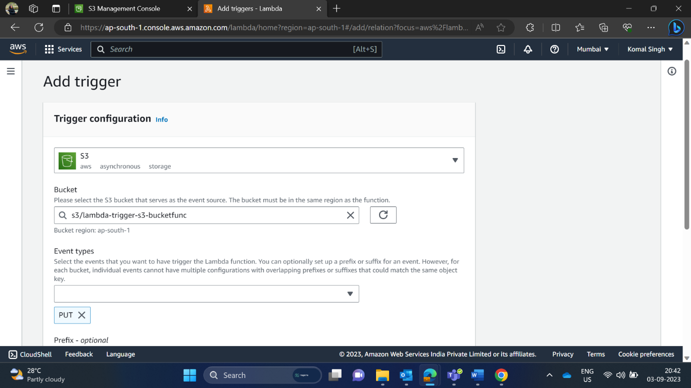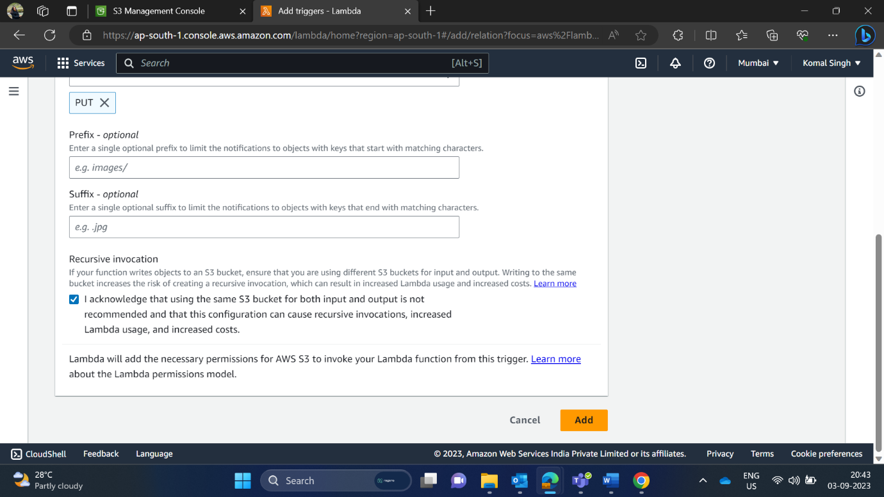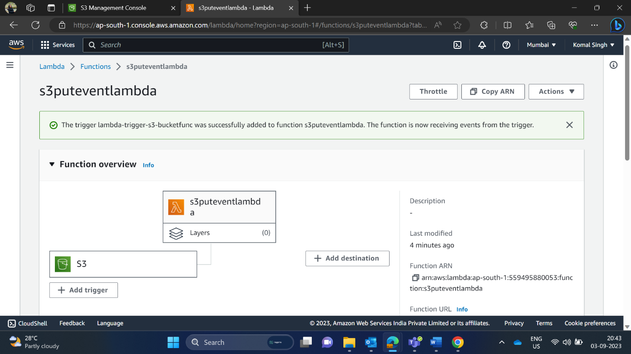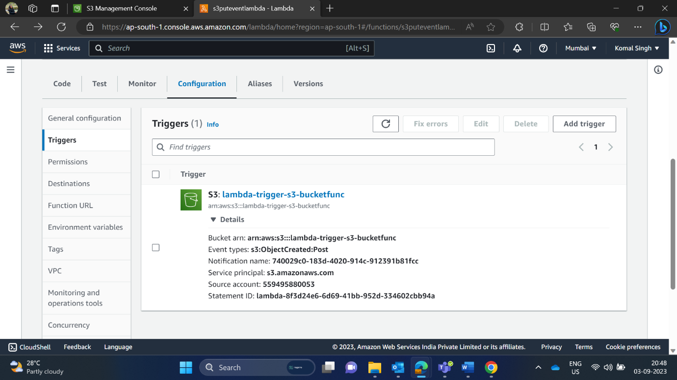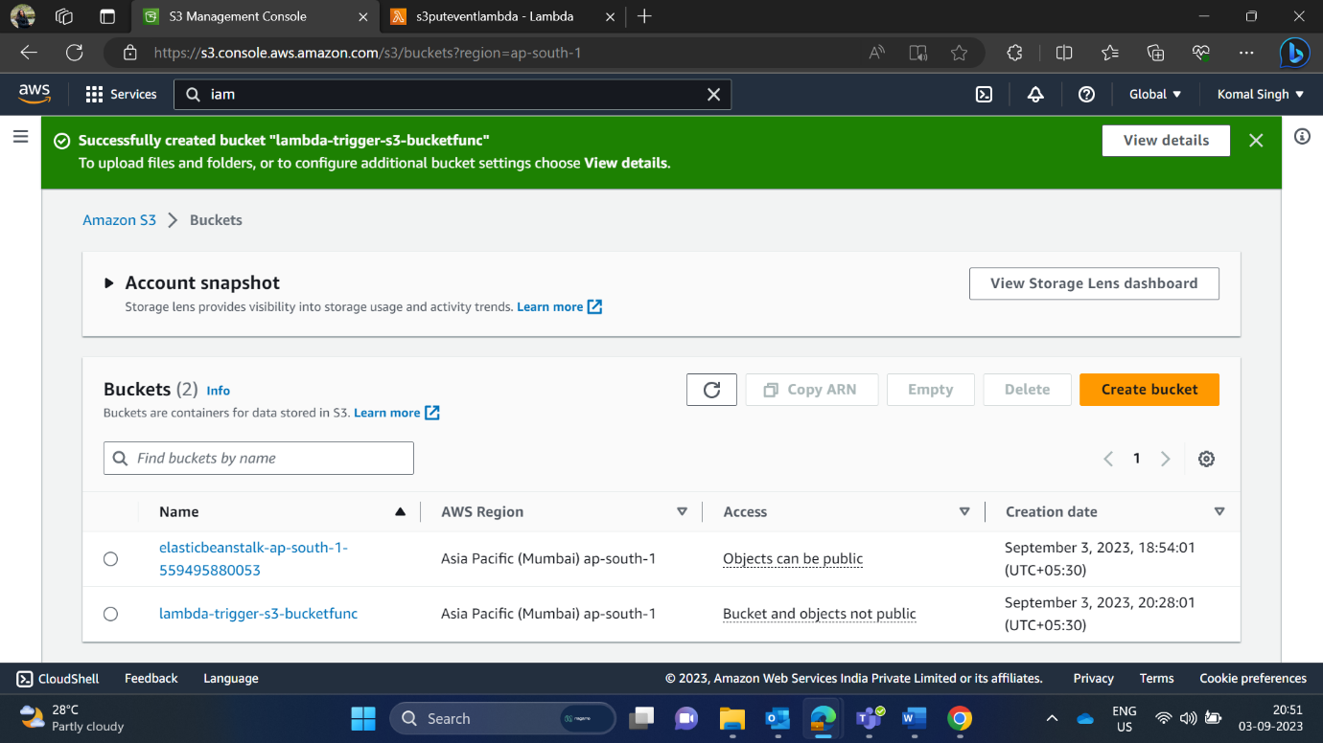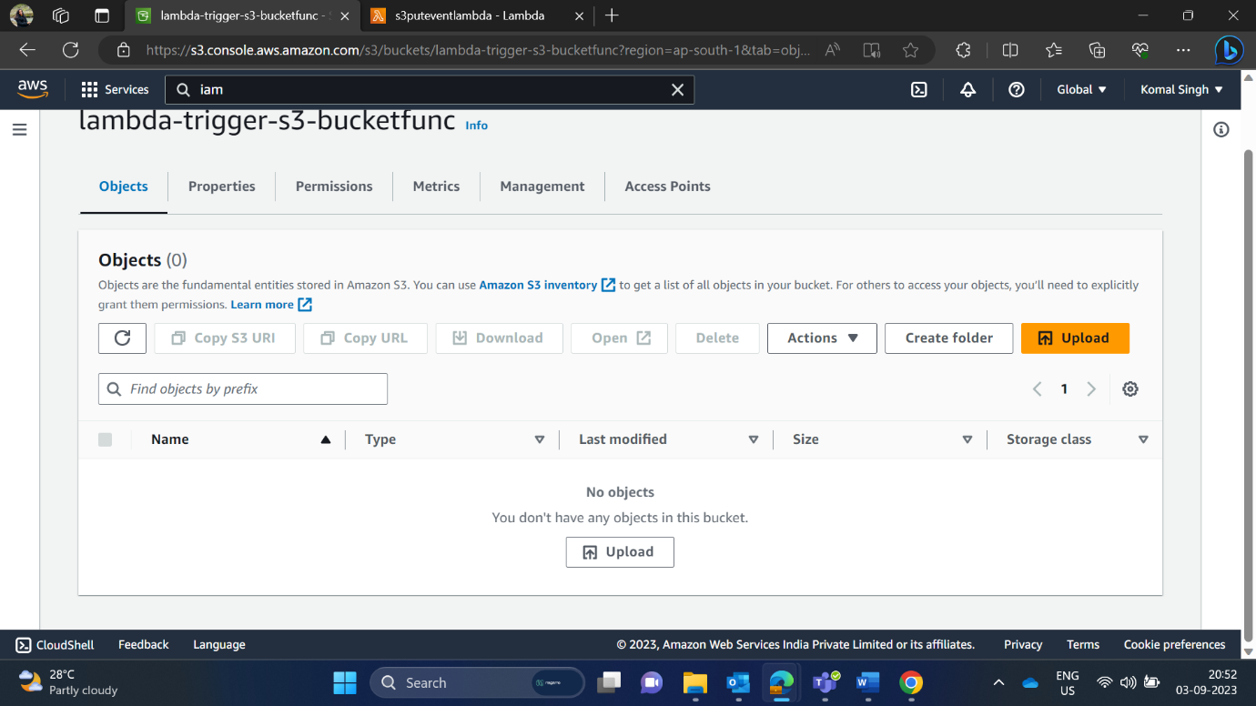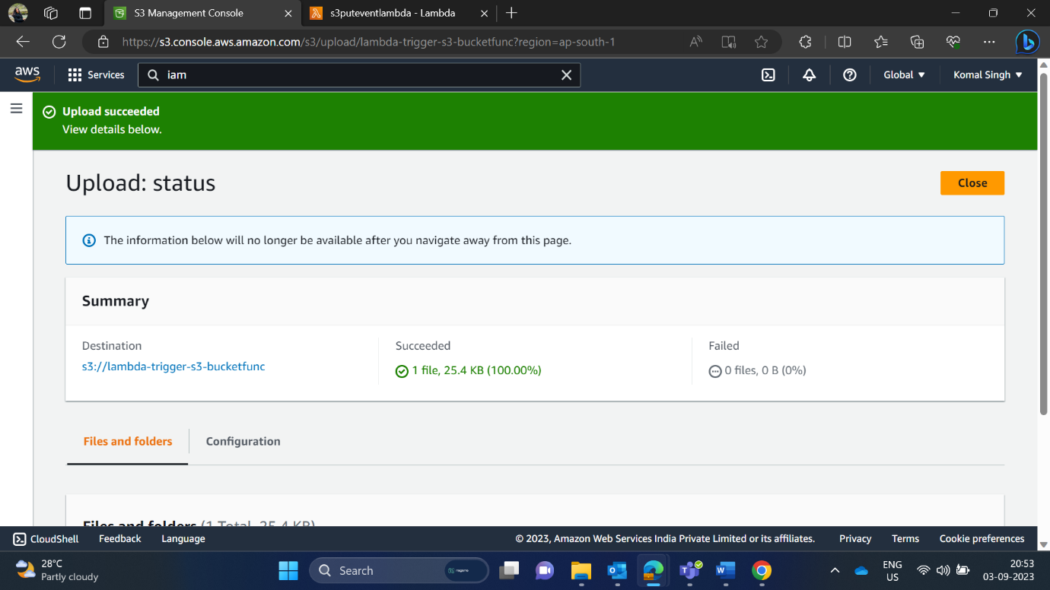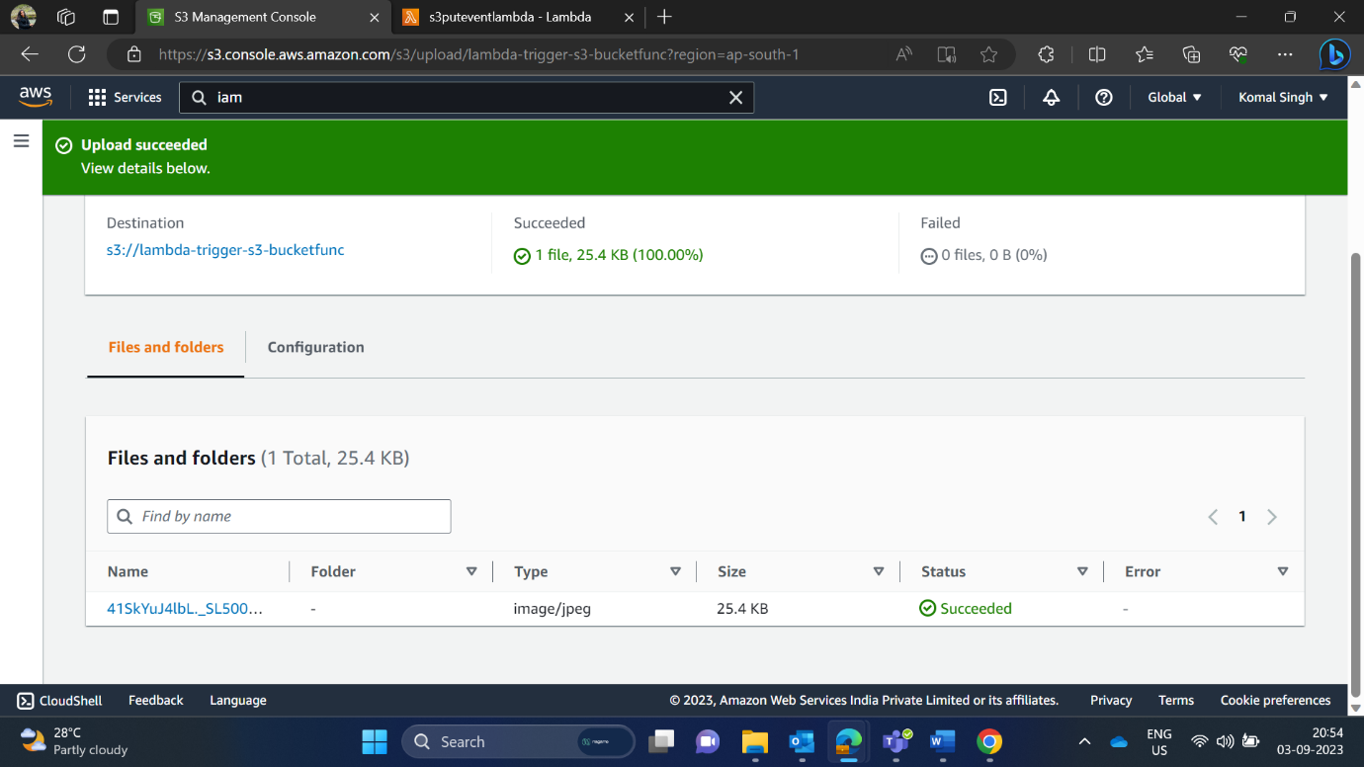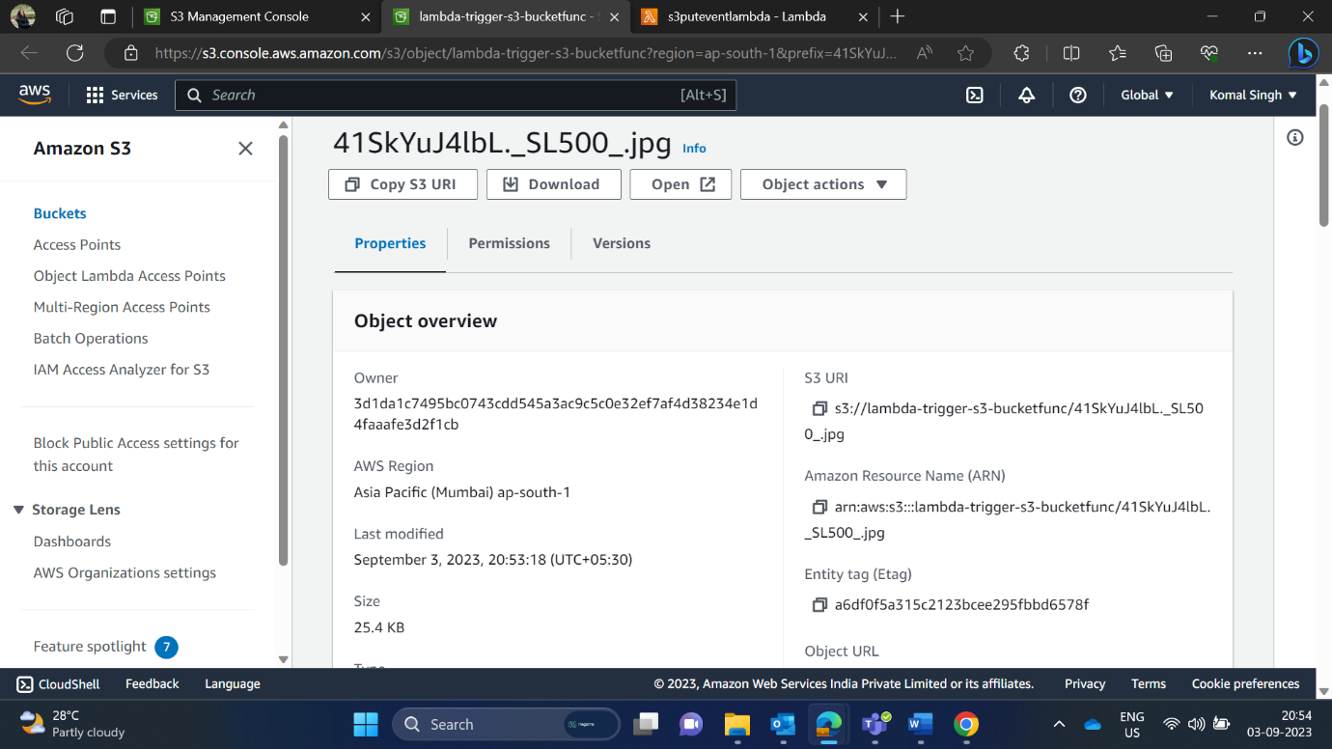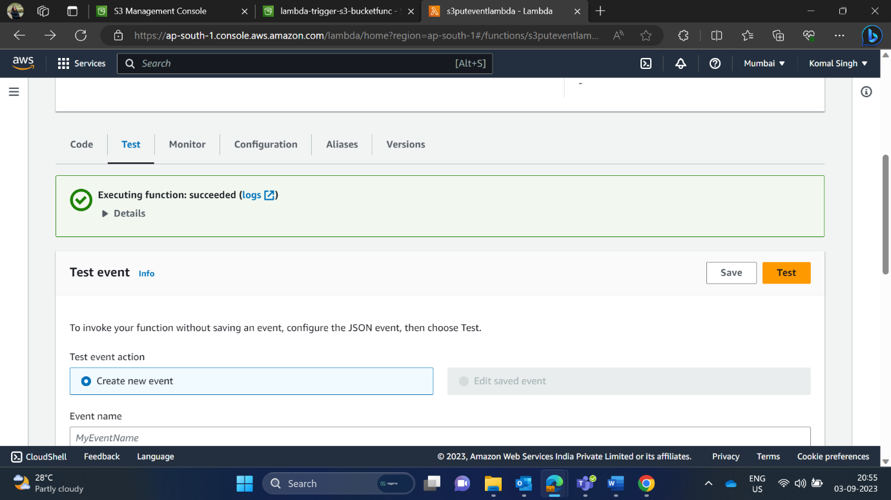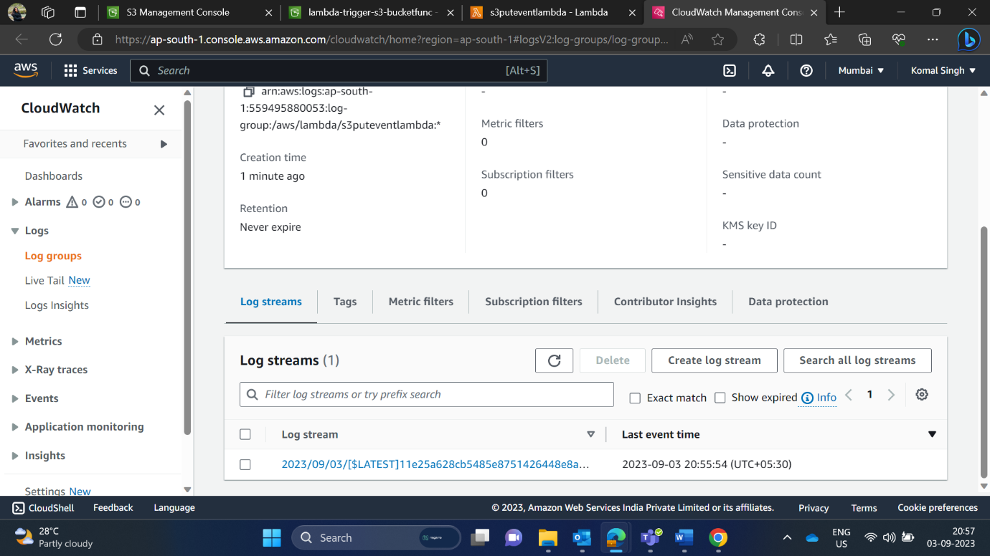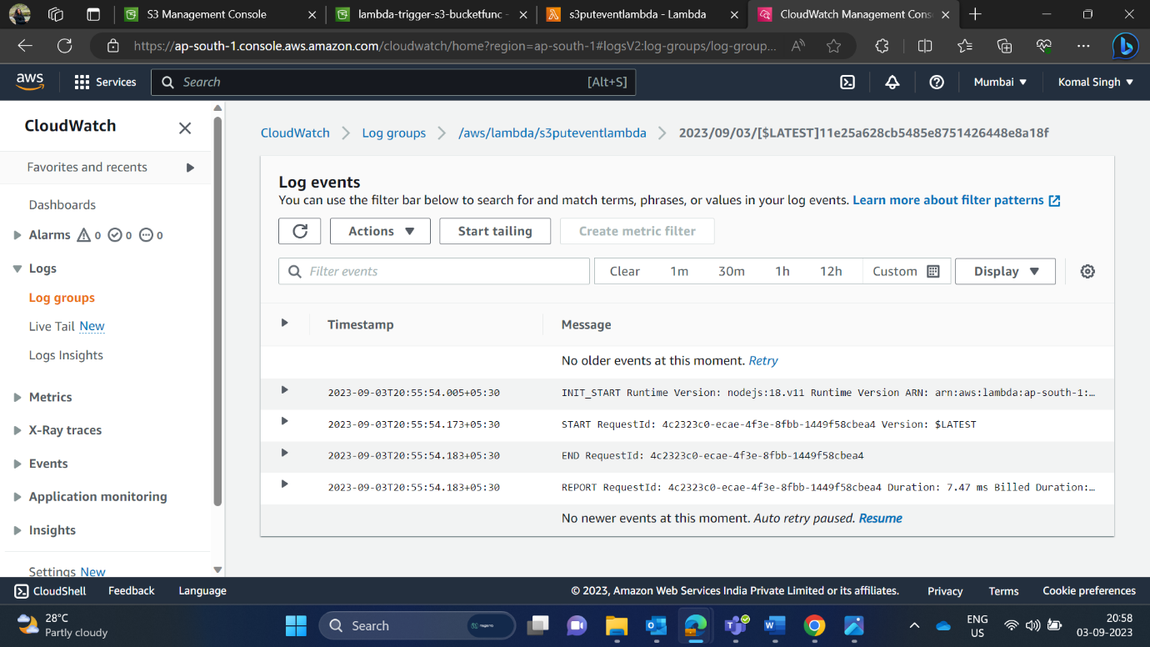

Now, search lambda. Choose Create Function. I have provided the name of my function as s3puteventlambda.

Again, I must choose a role, so I searched IAM and created a role for lambda.

Here, my existing role name is “S3ReadEventRole” which I’d created in IAM.

I have successfully created a lambda. Now, choose Add Trigger button.

In Trigger, I have chosen the bucket which I’d created earlier and now, my trigger has successfully created.

Snapshot 1: Description of my trigger.

Snapshot 2: Opened my S3 bucket and chosen lambda-trigger-s3-bucketfunc.

Snapshot 1: After clicking on upload, I’d uploaded a .jpg file.

Snapshot 2: My file has successfully uploaded.

Here, we can see the description of the successfully uploaded file.

Here, I am monitoring my uploaded file. It can read the file.

Here, in CloudWatch management console, a function is triggered. Hence, the operation has been successfully performed.